Functional Architecture Design

数字校园
V 1.0

September 7, 2001

Document Control

Change Record

Date | Author | Version | Change Reference
9/7/2001 | Jack Huang | 1.0
9/7/2001 | Robin Liu | 1.0

Reviewers

Date | Name | Position
9/10/2001 | Jack Huang | Architecture
9/10/2001 | Erin Wang | Project Manager
9/10/2001 | John Wang | Director of Engineers
9/10/2001 | Robin Liu | Architecture
9/10/2001 | Eric | Architecture

Approved By

Name | Position | Signature | Date
The copy numbers referenced above should be written into the Copy Number space on the cover of each distributed copy. If the document is not controlled, you can delete this table and the Copy Number label from the cover page.

CONTENTS
1. Introduction 6
1.1. Purpose 6
1.2. Scope 6
1.3. Overview 6
2. Architectural Representation 6
3. Architectural Goals and Constraints 7
4. Use-Case View 7
Use-Case Realizations 7
Use-Case Model 8
Actors 8
Use Cases 8
<Use Case Name> 8
Use Case - <Use Case Name> 9
ESchool 9
Use Case Diagram - Global View of Actors and Use Cases 9
Use Case Diagram - after school 10
Use Case - Inschool 12
Use Case - System manage 13
inschool 15
Use Case - checkOnWorkAttendance 15
Use Case - communication 16
Use Case - examination 16
Use Case - inspection 20
checkOnWorkAttendance 21
Use Case - browse students info 21
Use Case - browse teacher info 22
Use Case - calling 22
Use Case - group student(same with group talking) 24
Use Case - modify student info 24
Use Case - modify teacher info 25
communication 27
Use Case - communicateWithVoice 27
Use Case - communicateWithWord 27
Use Case - demonstrate 27
Use Case - groupTalking 29
Use Case - grouping 32
Use Case - question and answer 32
Use Case - talkwithteacher 35
examination 39
Use Case - browse exam content 39
Use Case - browse student group 40
Use Case - choose exam content 40
Use Case - choose examination 40
Use Case - choose student group 42
Use Case - exam start 43
Use Case - handin by teacher 44
Use Case - save answer paper 45
Use Case - student get exam content 45
Use Case - student hand in 46
Use Case - system hand in 47
Use Case - timing start 47
inspection 48
Use Case - capture screen 48
Use Case - dark screen 50
Use Case - warning 53
after school 55
Use Case - attribute (homework,preparation,review,selfexercise,listening) set 55
Use Case - check homework 56
Use Case - checkexam answerpaper 57
Use Case - content attribute(homework, paraperation, review, selfexercise, listening)4student 58
Use Case - content attribute4teacher 59
Use Case - content upload 60
Use Case - content(homework,preparation,review,selfexercise,listening)list 60
Use Case - contentitemlist4student 61
Use Case - curriculum info 62
Use Case - exam analysis 62
Use Case - exam answerpaper 63
Use Case - exam attribute set 64
Use Case - exam attribute4student 65
Use Case - exam content list 65
Use Case - examlist4student 66
Use Case - examlist4teacher 66
Use Case - homework attibute4student 67
Use Case - homework list4teacher 68
Use Case - homeworkitemlist4student 68
Use Case - homeworklist4student 69
Use Case - listening list4teacher 69
Use Case - listeninglist4studnet 70
Use Case - preparation list4teacher 71
Use Case - preparationlist4student 71
Use Case - registry 72
Use Case - review list4teacher 73
Use Case - reviewlist4student 73
Use Case - search school data 74
Use Case - search score4student 75
Use Case - search score4teacher 76
Use Case - select content 77
Use Case - self info 78
Use Case - selfexercise list4teacher 78
Use Case - selfexerciselist4student 79
Use Case - student homepage 80
Use Case - student who unfinished homework 80
Use Case - teacher homepage 80
Use Case - upload homework after check4teacher 82
Use Case - uploadhomework4student 82
WebService 83
Use Case - BBS 83
Use Case - WebMail 83
Use Case - chatRoom 83
system management 83
Use Case - curricular management 83
Use Case - material management 84
Use Case - privilege management 84
Use Case - student management 84
Use Case - teacher management 85
5. Logical View 85
5.1. Overview 85
5.2. Architecturally Significant Design Packages 85
5.2.1课堂教学部分 86
5.2.2课外教学部分 94
6. Process View 99
7. Deployment View 99
8. Implementation View 100
8.1. Overview 100
8.2. Layers 100
8.2.1课堂教学： 100
8.2.2 课外教学 101
9. Data View 101
10. Quality 101
11. Supplementary Specification 102
11.1. Usability 102
11.2. Reliability 102
11.3. Performance 102
11.4. Scaling Issues 102
11.5 Software condition requirement 102

Introduction

Purpose
This document provides a comprehensive architectural overview of the system, using a number of different architectural views to depict different aspects of the system. It is intended to capture and convey the significant architectural decisions which have been made on the system.

Scope
This document is the bridge between the requirement analysis and the software analysis. The more detail Business View and Use Case View will be presented and the software function architecture will be defined.

Overview
The rest of this document will be organized as architectural representation, architectural goals and constraints, Use-Case, Logical, Process, Deployment and implementation view.

Architectural Representation
This document is composed by Use-Case, Logical, Process, Deployment and implementation view:
Use-Case view will present a description of a set of sequences of actions, including variants, that a system performs that yields an observable result of value to the actor(teacher, student or system manager). We will try to describe the use cases by the use-case diagram, Activity/State diagram, sequence diagram.
Logical view will describes the architecturally significant parts of the design model, such as its decomposition into subsystems and packages. For each significant package, its decomposition into classes and class utilities. It will introduce architecturally significant classes and describe their responsibilities, as well as a few very important relationships, operations, and attributes.
Deployment view will describes the physical network (hardware) configurations on which the software is deployed and run. At a minimum for each configuration it should indicate the physical nodes (computers, CPUs) that execute the software, and their interconnections (bus, LAN, point-to-point, and so on.) Also include a mapping of the processes of the Process View onto the physical nodes.
Implement view will describes the overall structure of the implementation model, the decomposition of the software into layers and subsystems in the implementation model, and any architecturally significant components.

Architectural Goals and Constraints
The architecture of this software will be modeled with the method of use-case oriented, and the different object logical levels will be independent. That means if one object logical level is modified, the other level can run will with very little change.
The eschool software will realize most possibility to be independent with system operation.
The part of software of school server will be programmed by pure java and can run in any system operations, if it owns ejb container compatible with J2EE server of SUN, jsp server compatible with tomcat and web server compatible with apache.
The part of software that will run in the computers of students and teachers should also be programmed almost all java language except JMF packages.

Use-Case View
根据需求分析及技术分析，将系统分成三大部份：课堂教学部分，课外教学部分与附加网页系统。
课堂教学部分包括：在线考试，课堂交流，监视监听，座次考勤四个子系统；
课外教学部分包括：考试准备，自习系统，后台管理三个子系统；
附加网页系统包括：BBS，聊天室，WebMail服务三个子系统。

Use-Case Realizations

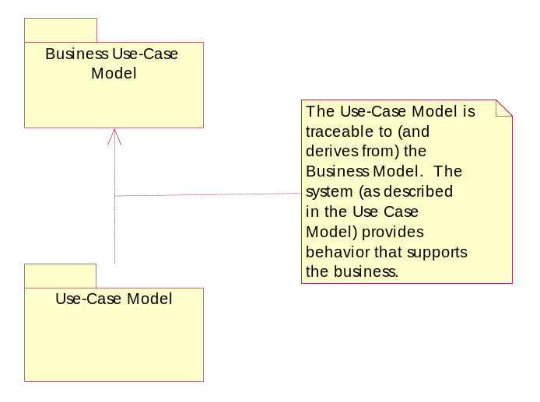

Use-Case Model

The Use-Case Model in Rational Unified Process contains a model of the behavior of a system which supports the business processes.

Actors

All Actors in the system are contained in this package. This is both as a way to organize the model, making it easier to understand, and to provide a way to manage the actors in a single configuration item.

If different individuals are responsible for different actors and their related artifacts, the actors should be organized into their own packages and placed under separate configuration control.

Use Cases

All Use Cases in the system are contained in this package. This is done strictly as a way to organize the model and make it easier to understand.

In order to version control use cases it is recommended to specify use case packages within this package.

Use Cases are often documented in a separate text file, use the Rational Unified Process template or use the use case template in Rational Requsite Pro.

Use Case Diagram - Architecturally Significant Use-Cases

<Use Case Name>

A separate package is recommended for each Use Case to facilitate access and version control of related use case artifacts.

Use Case - <Use Case Name>

Documentation:
<<The brief description of the use case is entered here. For guidance on what should go in this description, see the following Rational Unified Process references:

- Activity: Find Actors and Use Cases
- Guidelines: Use Case>>

List of Associations
<Use-Case Name> Communicates with <Use Case Name>
<Actor Name> Communicates with <Use Case Name>

Use Case Diagram - Local View - <Use Case Name>

ESchool

Use Case Diagram - Global View of Actors and Use Cases

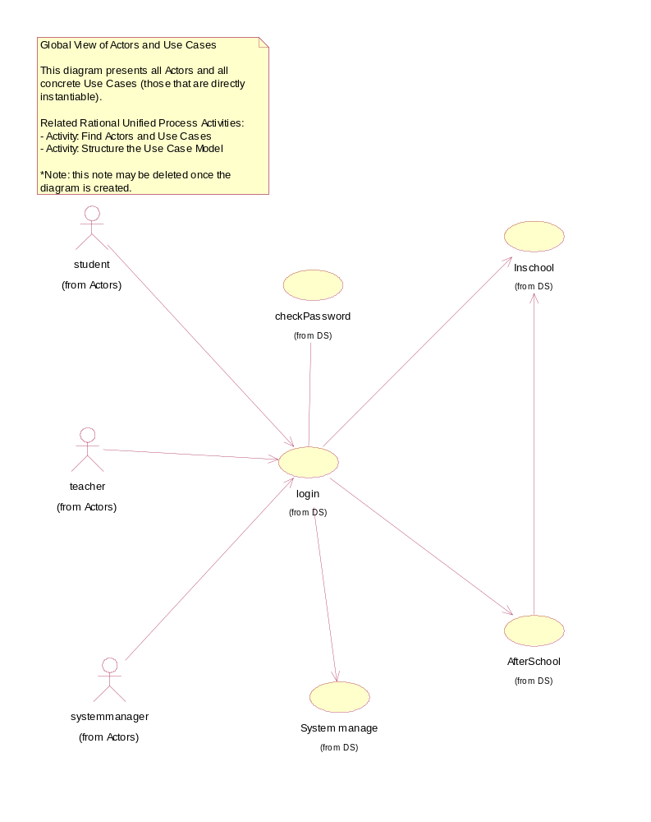

Use Case Diagram - after school
Description: User can perform exam preparation, homework, lessons preparation, lessons review, exercise and listening, use web service(BBS, WebMail, chatroom).

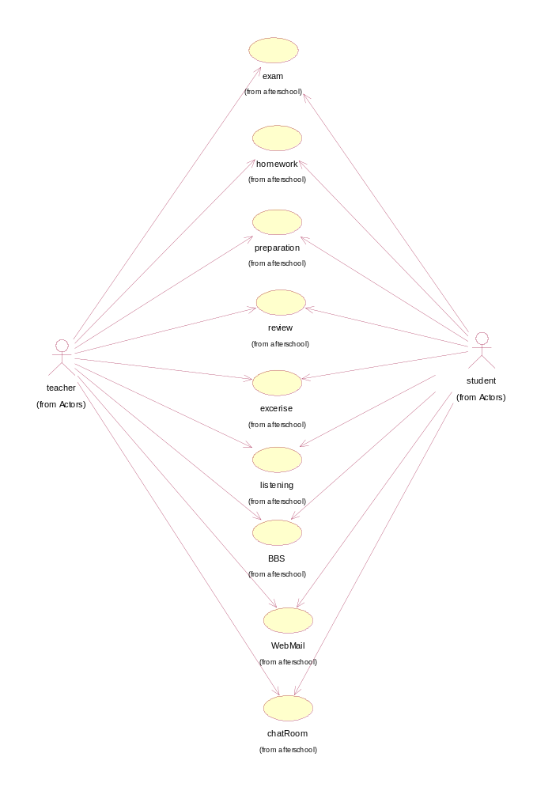
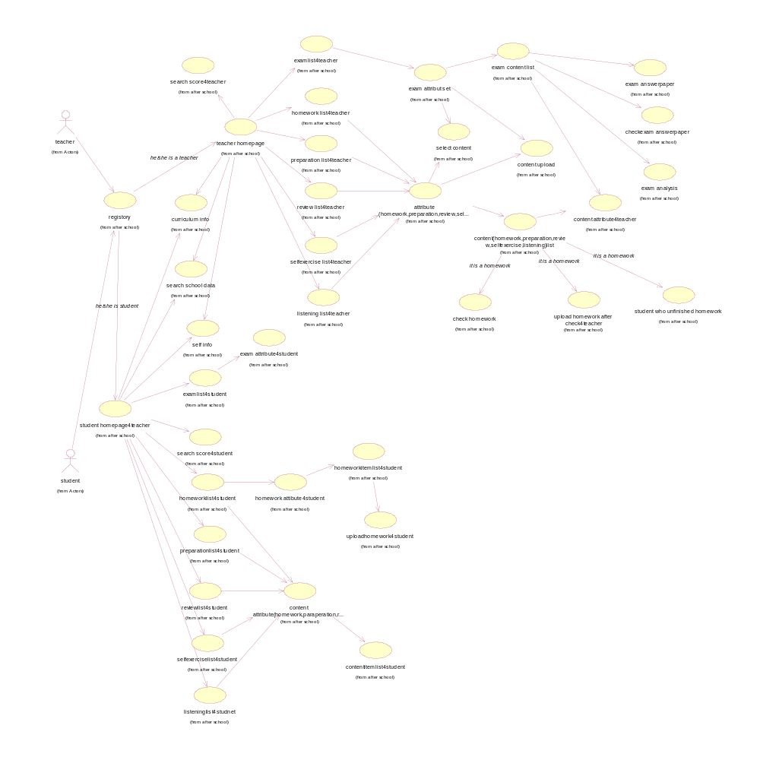

Use Case - Inschool
Description: User can perform examination, communication, classroom inspection and check on work attendance.

List of Associations
teacher Communicates with Inschool
student Communicates with Inschool
login Communicates with Inschool
AfterSchool Communicates with Inschool

Use Case Diagram - Inschool

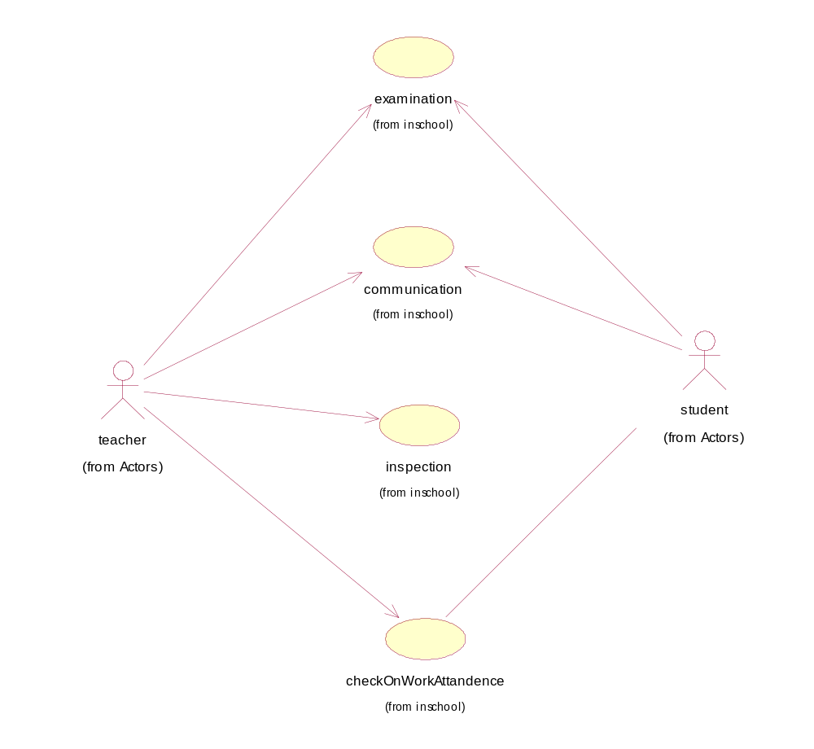

Use Case - System manage
Description: System manager can perform privilege management, student management, teacher management, curriculum management and school resource management.

List of Associations
login Communicates with System manage

Use Case Diagram - system management

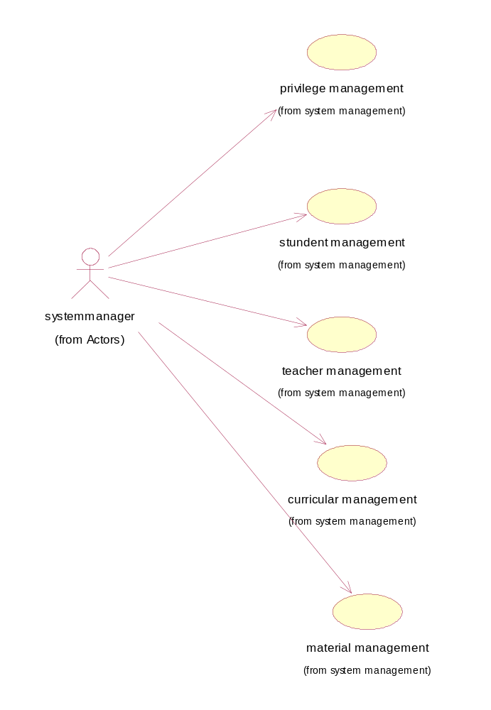

inschool

Use Case - checkOnWorkAttendance
Description: Teacher check on work attendance here.

List of Associations
teacher Communicates with checkOnWorkAttendance
student Communicates with checkOnWorkAttendance
student Communicates with checkOnWorkAttendance

Use Case Diagram - checkOnWorkAttendance

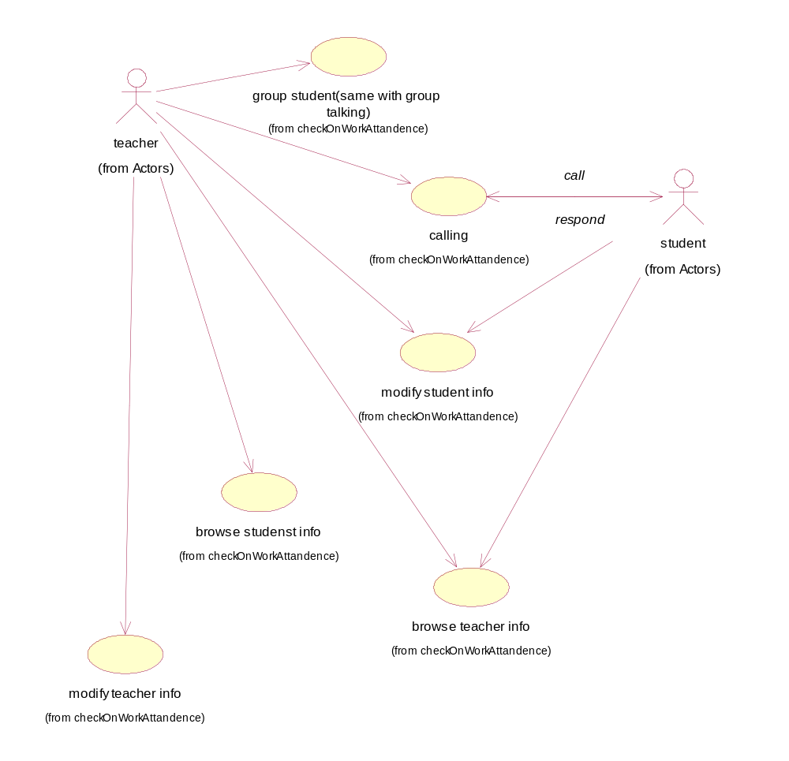

Use Case - communication
Description: Teacher and students make classroom communication here.

List of Associations
teacher Communicates with communication
student Communicates with communication

Use Case Diagram - communication

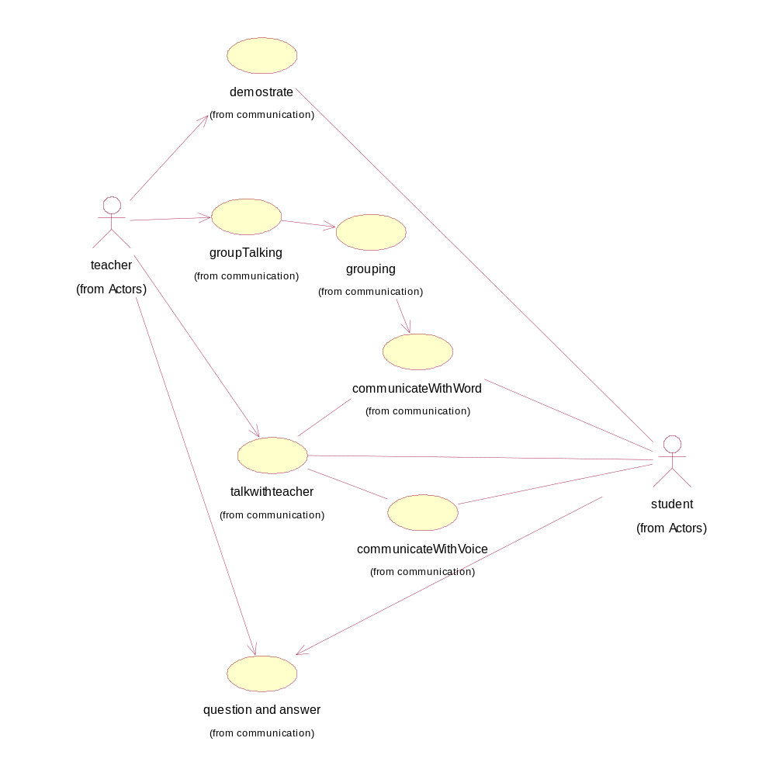

Use Case - examination
Description: Teacher and Students can perform examination online here.

List of Associations
teacher Communicates with examination
student Communicates with examination

Interaction Diagram - examination

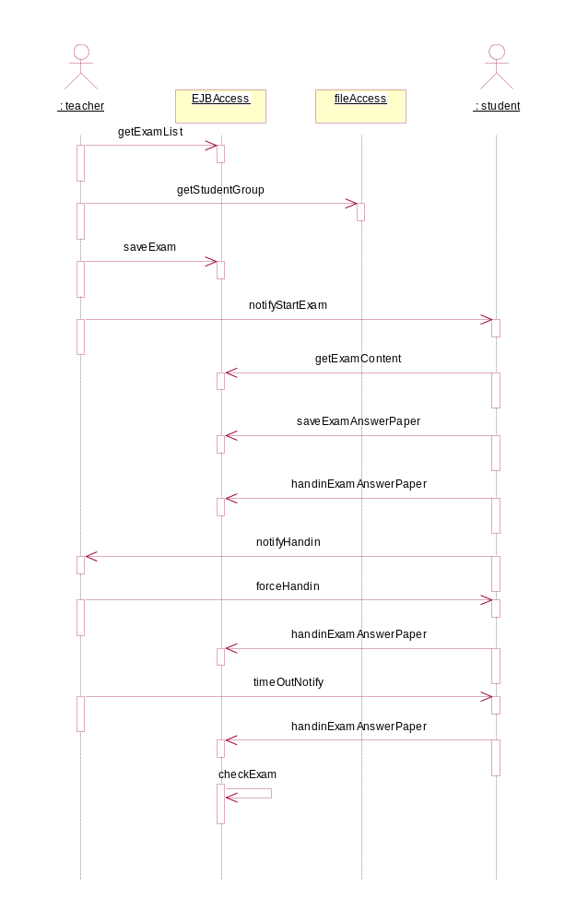

Interaction Diagram - examination

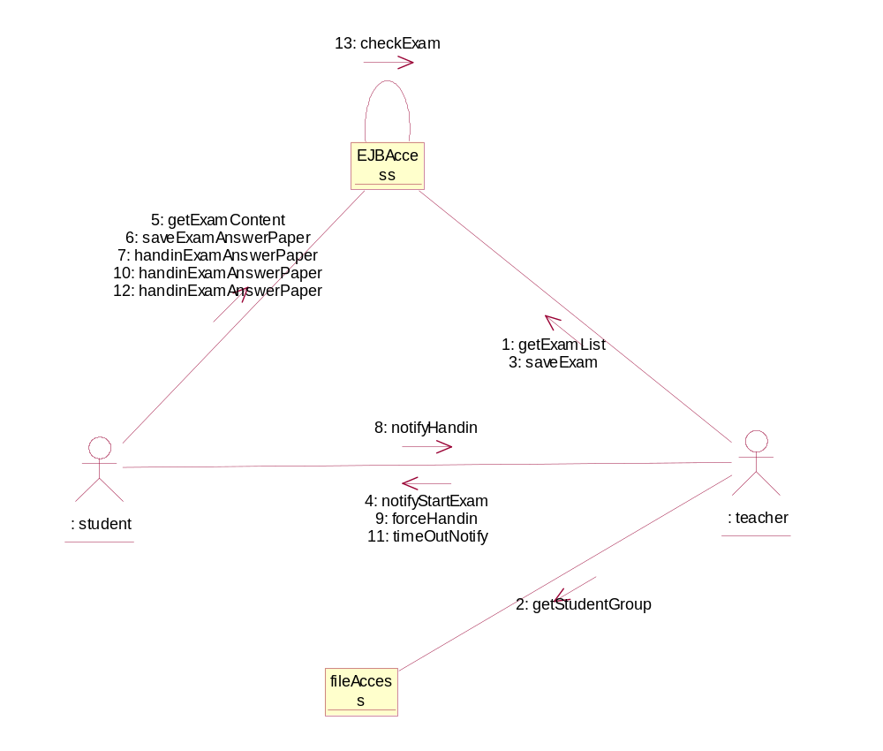

Use Case Diagram - Examination

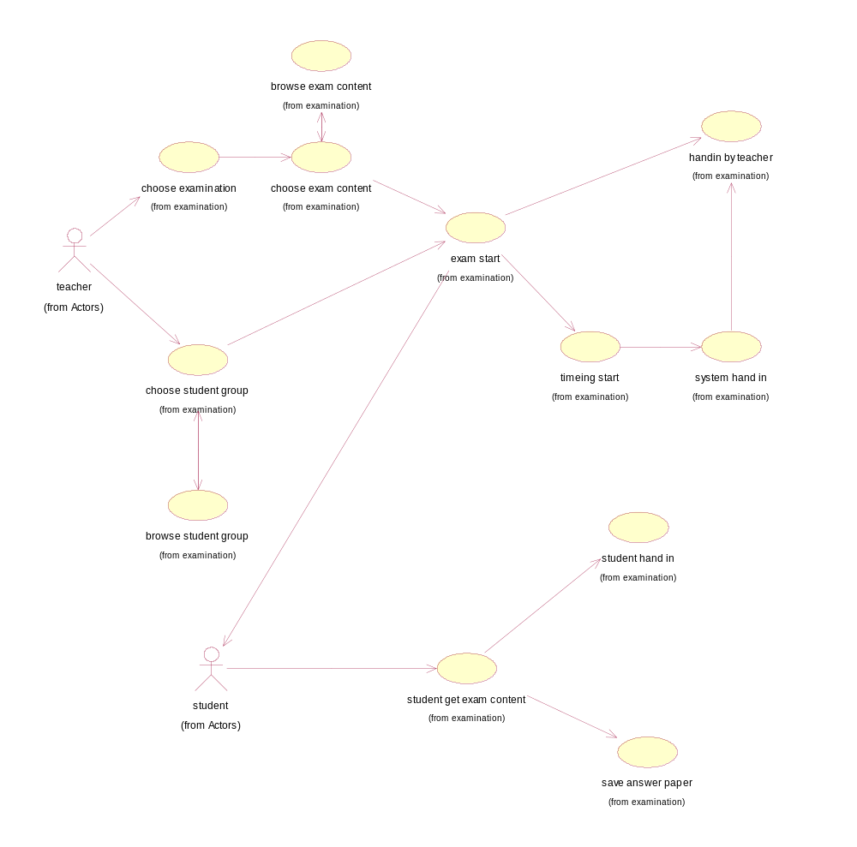

Use Case - inspection
Description: Teacher and students can perform classroom inspection here.

List of Associations
teacher Communicates with inspection
student Communicates with inspection
inspection Communicates with student
inspection Communicates with student

Use Case Diagram - inspection

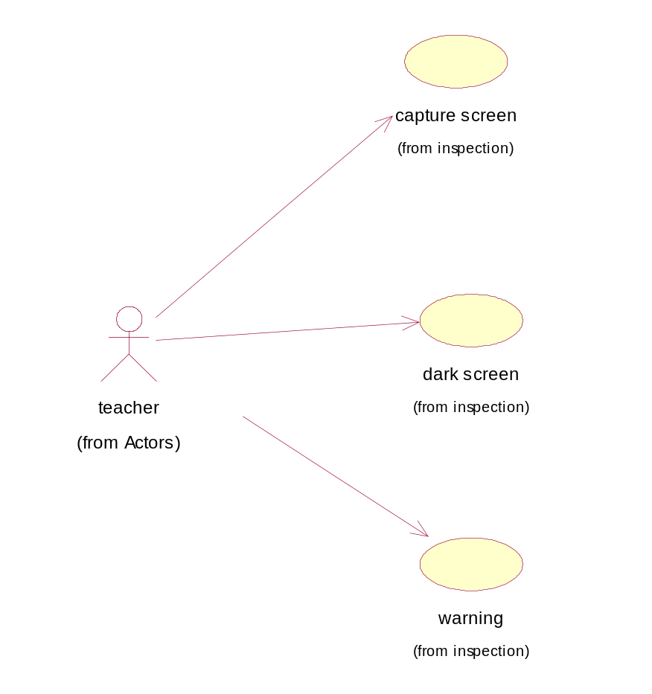

checkOnWorkAttendance

Use Case - browse students info
Description: Teacher or students and browse the information about students.

List of Associations
teacher Communicates with browse students info

Interaction Diagram - browse student info

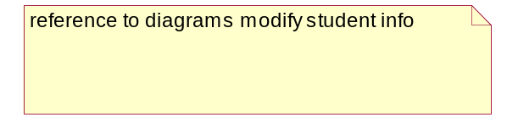

Use Case - browse teacher info
Description: Teacher and students can browse teachers information here.

List of Associations
teacher Communicates with browse teacher info
student Communicates with browse teacher info

Interaction Diagram - browse teacher info

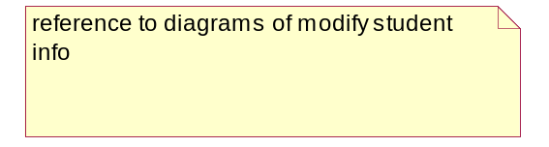

Use Case - calling
Description: Teacher and students can perform the classroom calling here.

List of Associations
teacher Communicates with calling
calling Communicates with student
student Communicates with calling

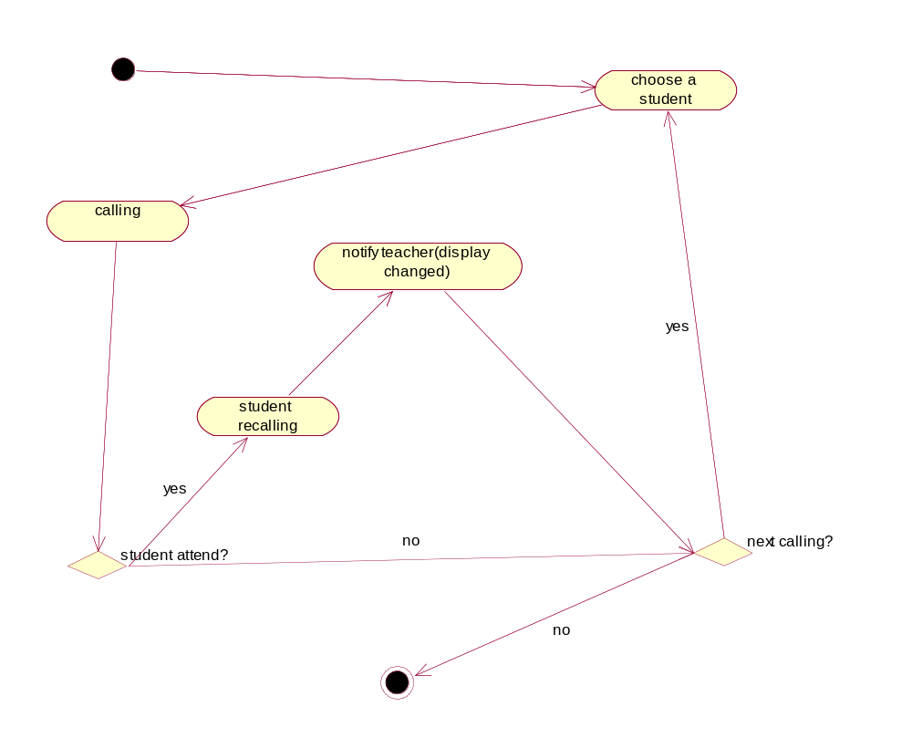

Interaction Diagram - calling

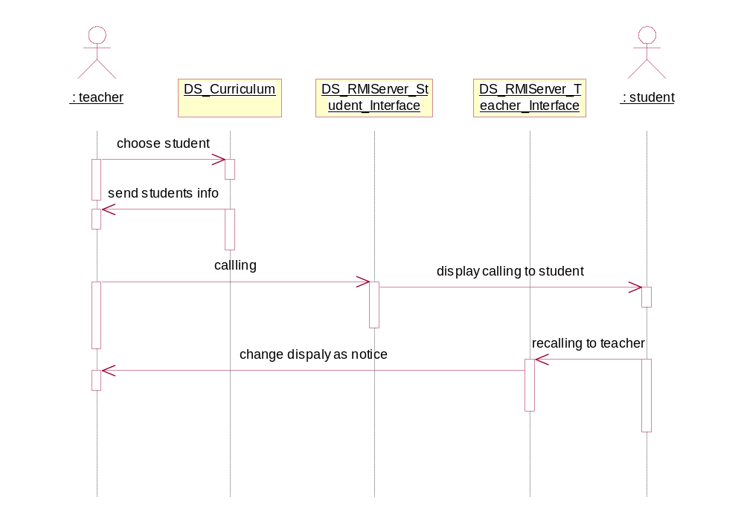

Use Case - group student(same with group talking)
Description: Teacher can group students here.

Documentation:
reference with group talking in communication/inschool

List of Associations
teacher Communicates with group student(same with group talking)

Use Case - modify student info
Description: Teacher or student can modify the information of student here.

List of Associations
student Communicates with modify student info
teacher Communicates with modify student info

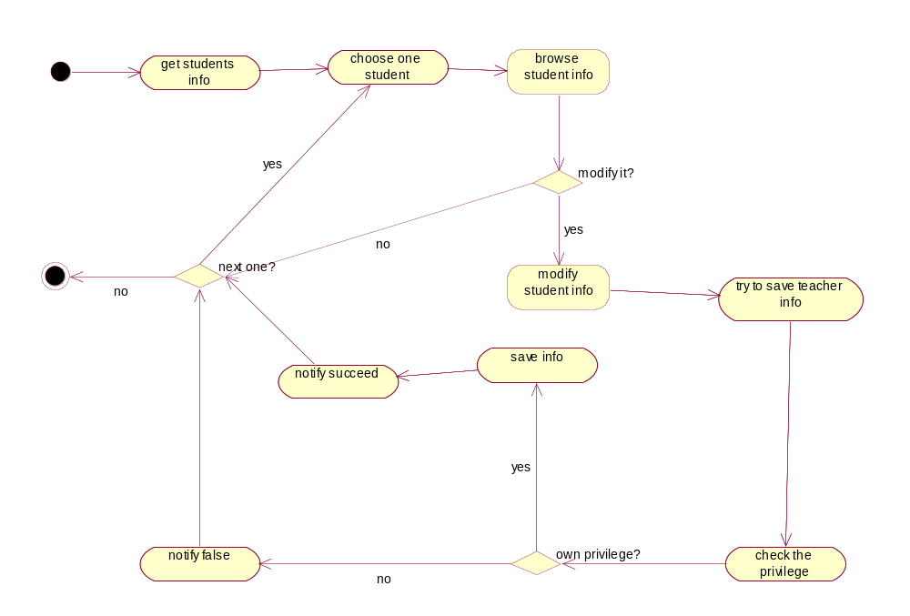

Interaction Diagram - modify student info

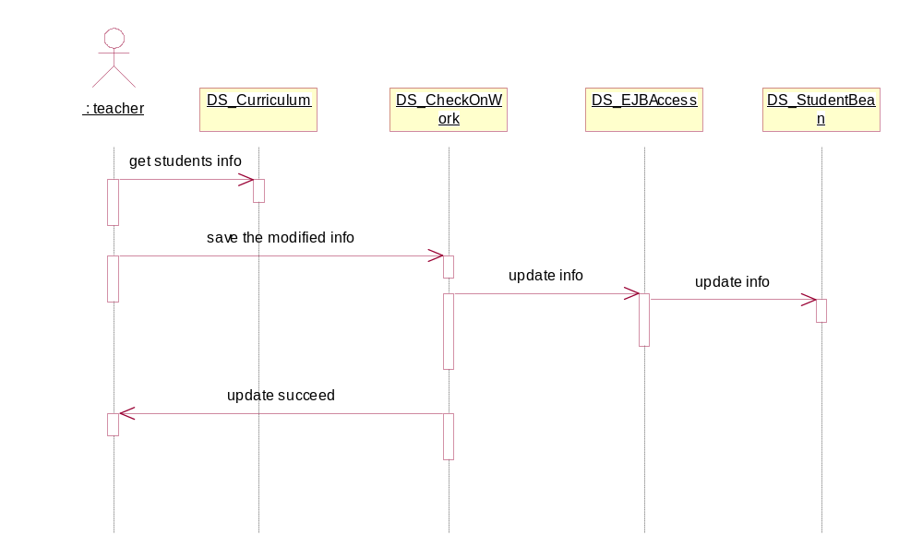

Use Case - modify teacher info
Description: Teacher can modify the information of teacher here.

List of Associations
teacher Communicates with modify teacher info

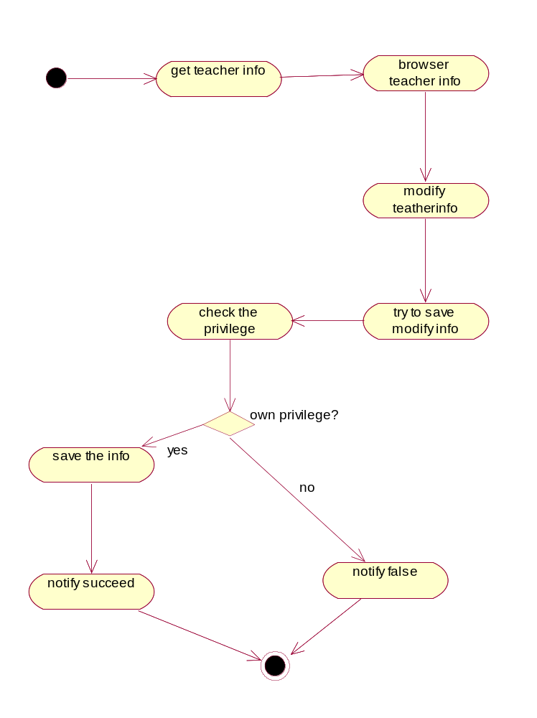

Interaction Diagram - modify teacher info

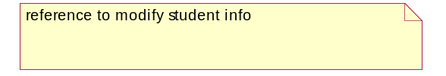

communication

Use Case - communicateWithVoice
Description: Students and teacher communicate with voice here.

List of Associations
student Communicates with communicateWithVoice
talkwithteacher Communicates with communicateWithVoice
student Communicates with communicateWithVoice
communicateWithVoice Communicates with student
talkwithteacher Communicates with communicateWithVoice

Use Case - communicateWithWord
Description: Students and teacher communicate with text here.

List of Associations
groupTalking Communicates with communicateWithWord
student Communicates with communicateWithWord
talkwithteacher Communicates with communicateWithWord
communicateWithWord Communicates with student
grouping Communicates with communicateWithWord
communicateWithWord Communicates with talkwithteacher

Use Case - demonstrate
Description: Teacher can demonstrate his screen to the students here.

List of Associations
teacher Communicates with demonstrate
student Communicates with demonstrate
demonstrate Communicates with student

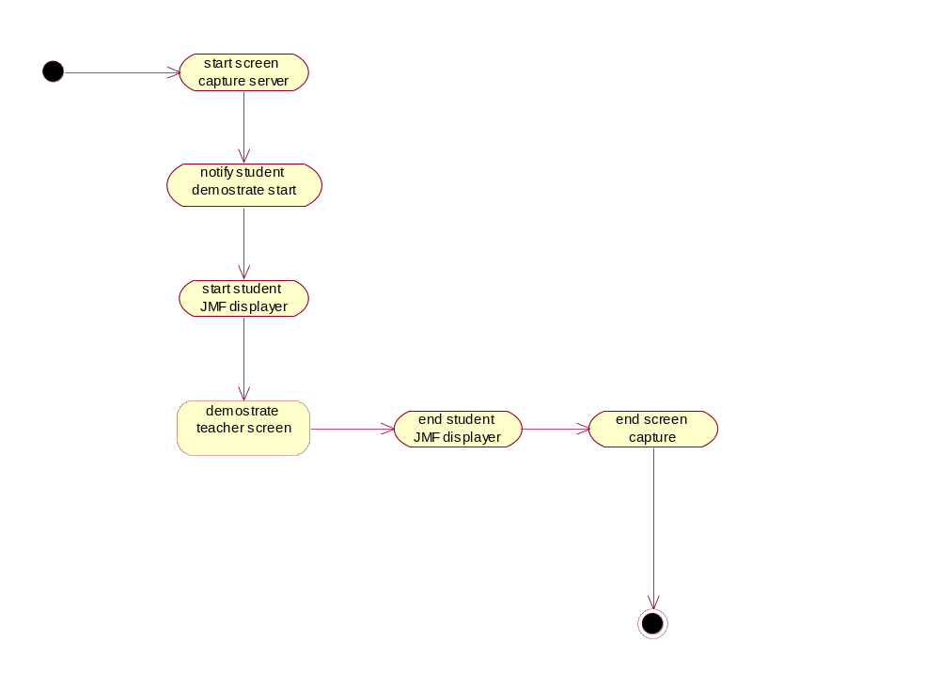

Interaction Diagram - demonstrate

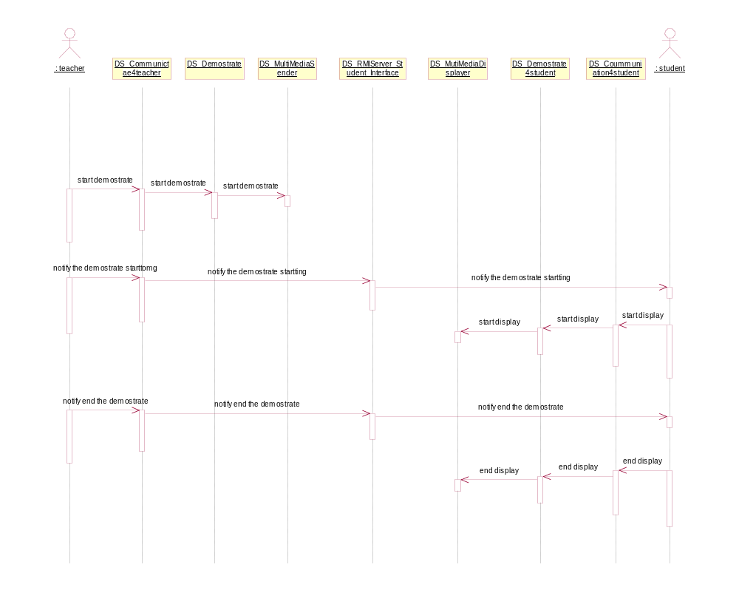

Interaction Diagram - demostrate

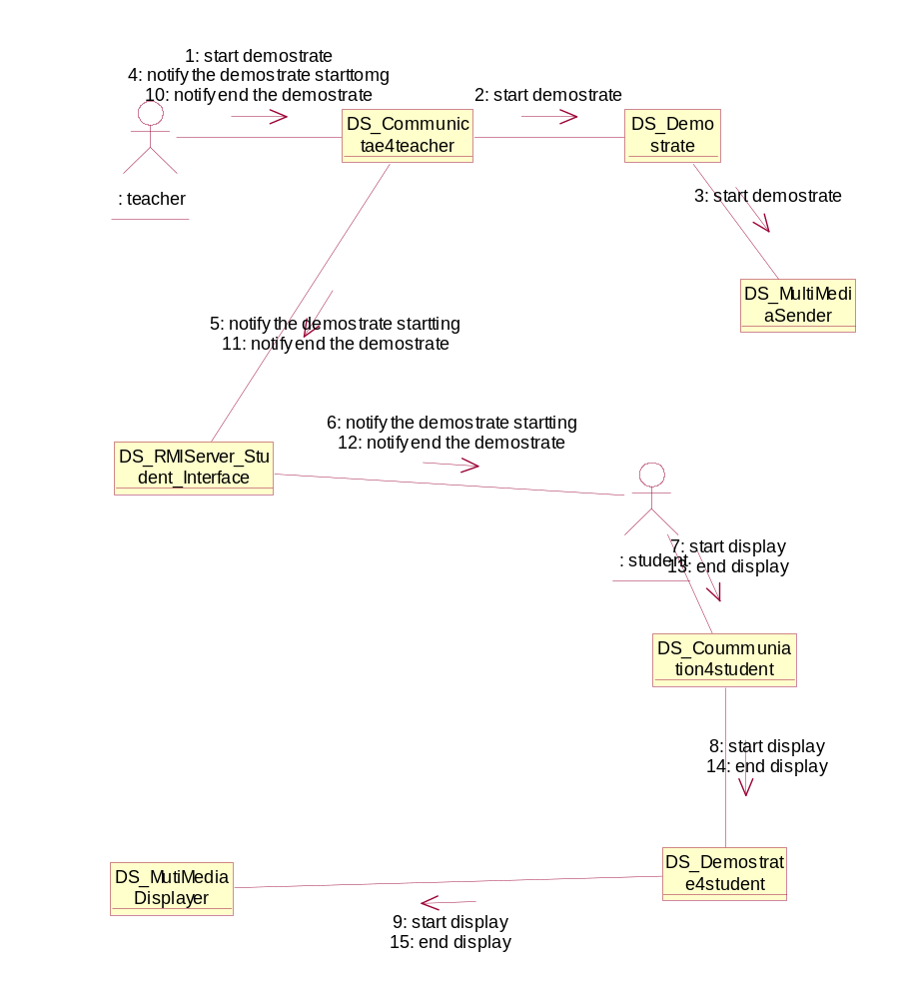

Use Case - groupTalking
Description: Students and teacher make group talking here.

List of Associations
teacher Communicates with groupTalking
groupTalking Communicates with grouping
groupTalking Communicates with communicateWithWord

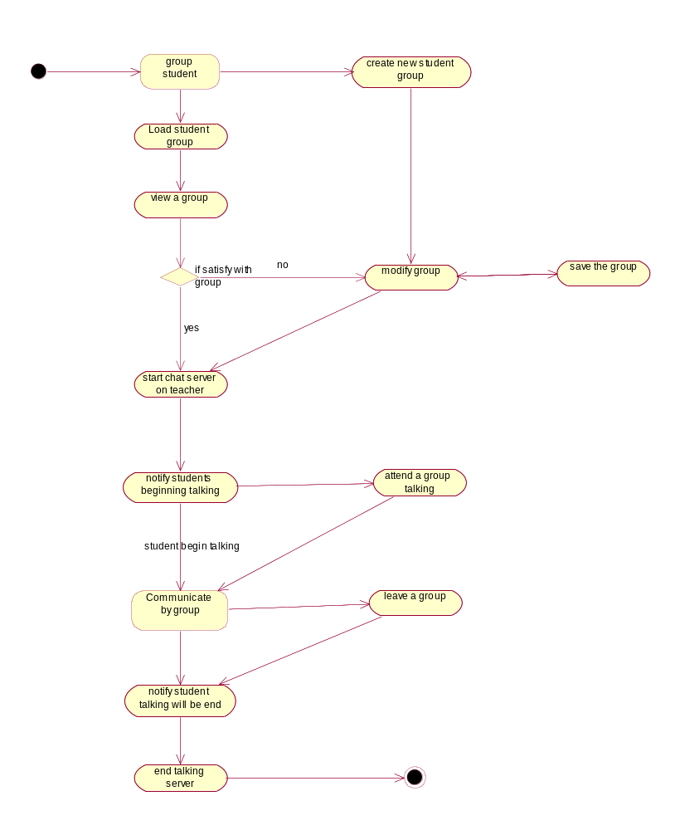

Interaction Diagram - grouptalking

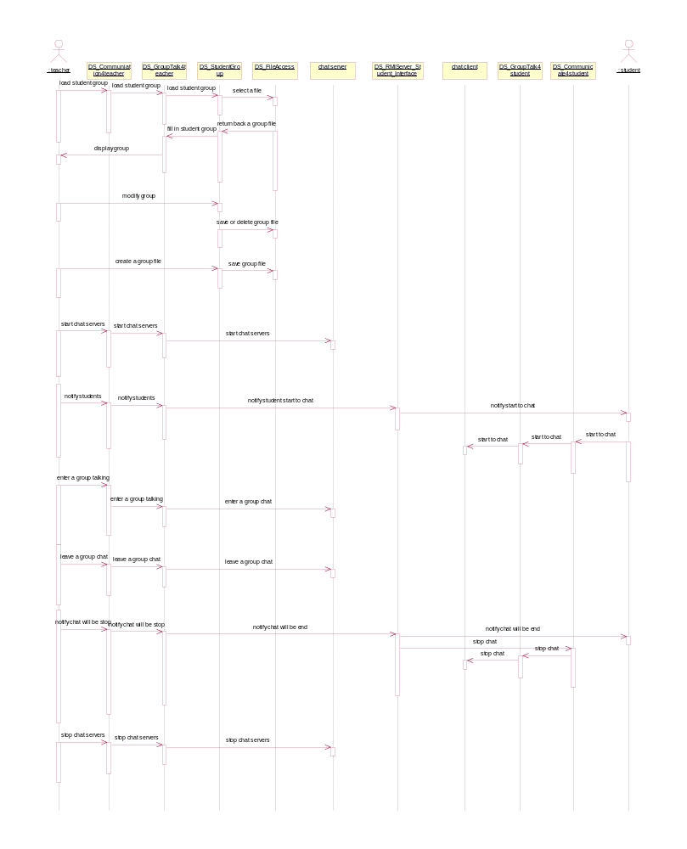

Interaction Diagram - grouptalking

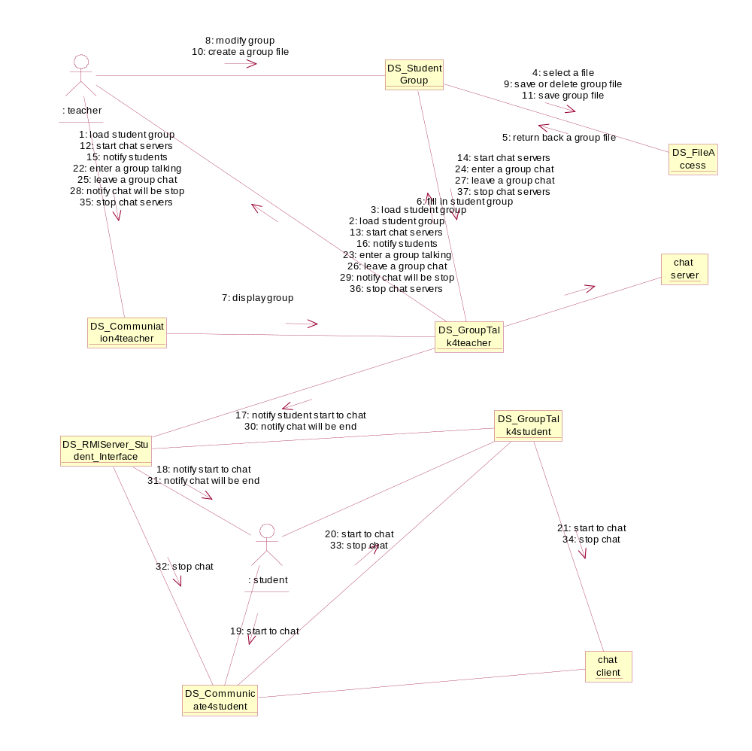

Use Case - grouping
Description: Teacher grouping students here.

List of Associations
grouping Communicates with student
groupTalking Communicates with grouping
grouping Communicates with communicateWithWord

Use Case - question and answer
Description: Teacher question students, and students answer the question as first raise hand first answer here.

List of Associations
teacher Communicates with question and answer
student Communicates with question and answer

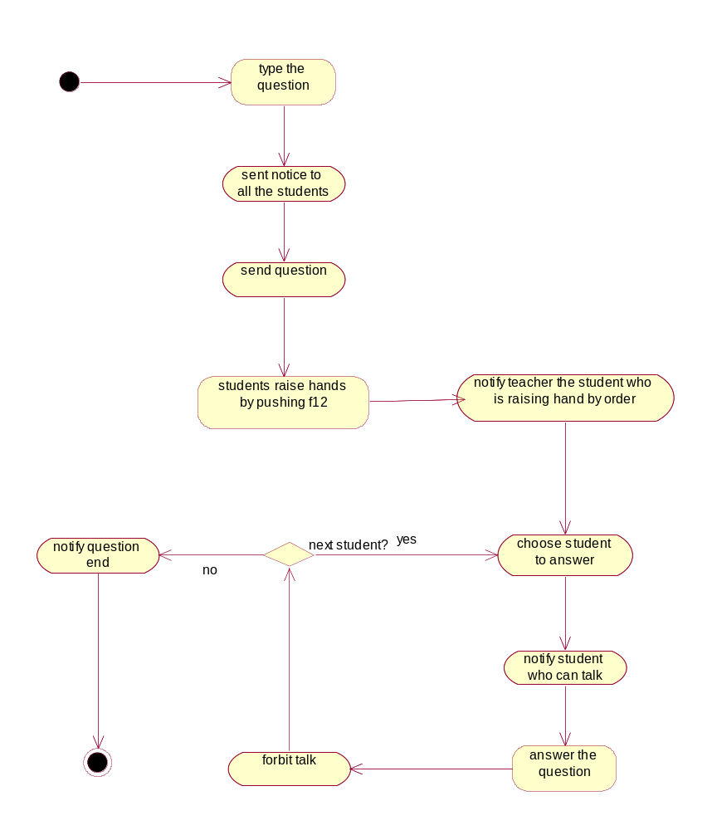

Interaction Diagram - question and answer

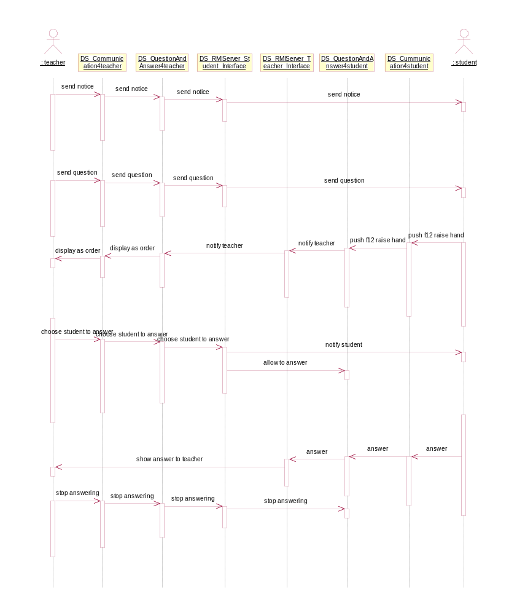

Interaction Diagram - question and answer

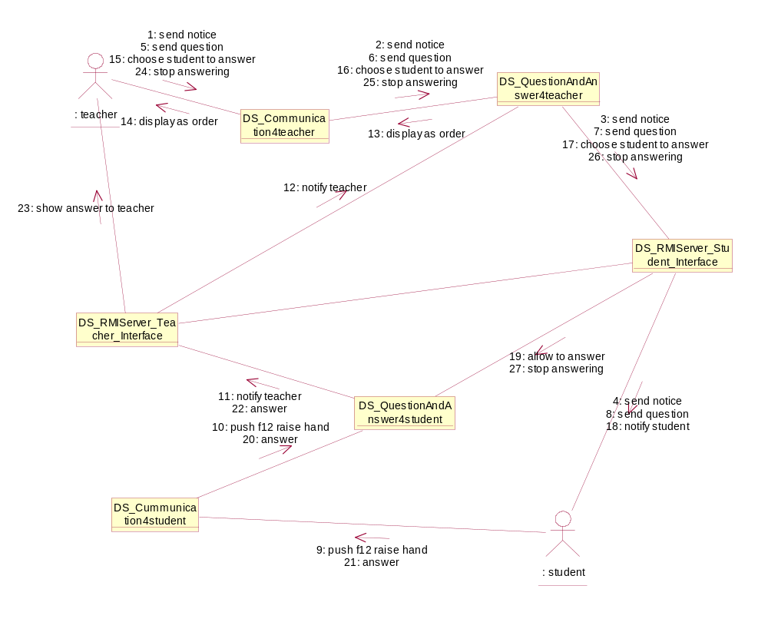

Use Case - talkwithteacher
Description: Teacher talk with students by (voice or text) here.

List of Associations
teacher Communicates with talkwithteacher
talkwithteacher Communicates with student
talkwithteacher Communicates with communicateWithVoice
talkwithteacher Communicates with communicateWithWord
communicateWithWord Communicates with talkwithteacher
talkwithteacher Communicates with communicateWithVoice

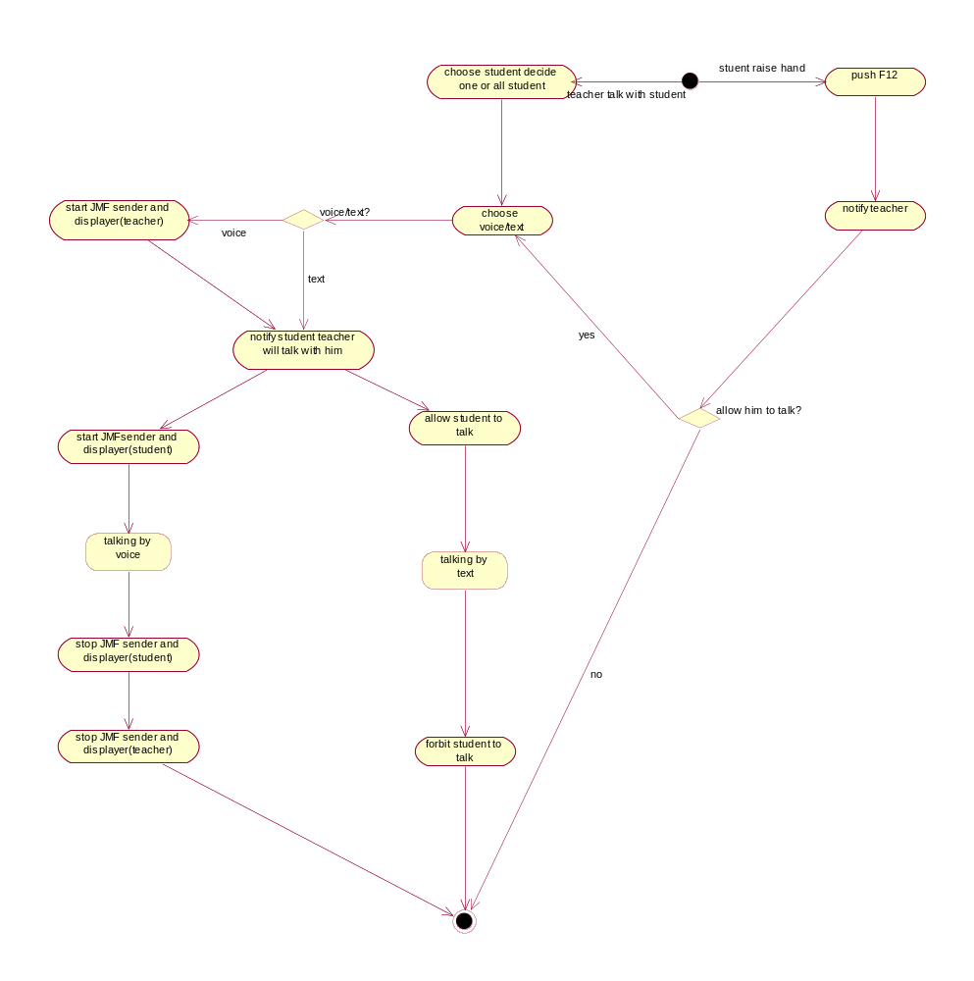

Interaction Diagram - talk with teacher by voice

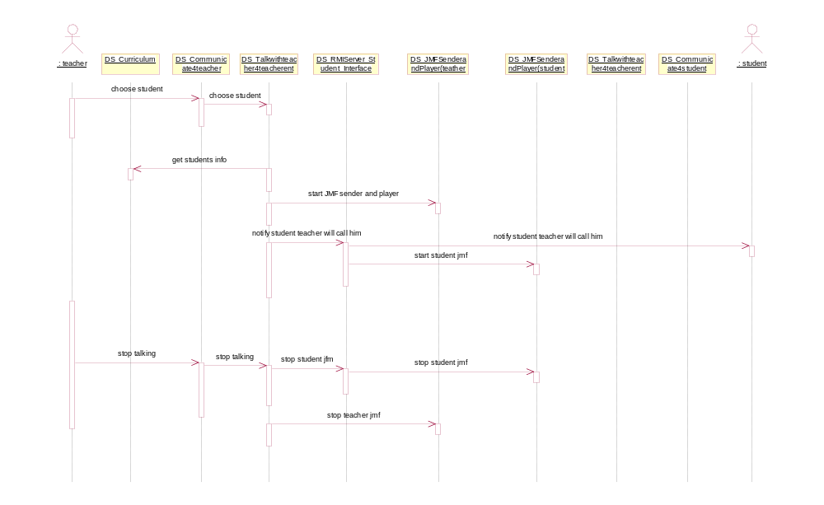

Interaction Diagram - ask teacher

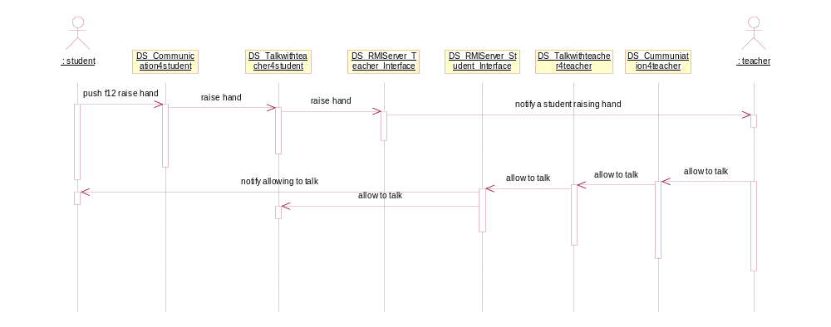

Interaction Diagram - talk with teacher by text

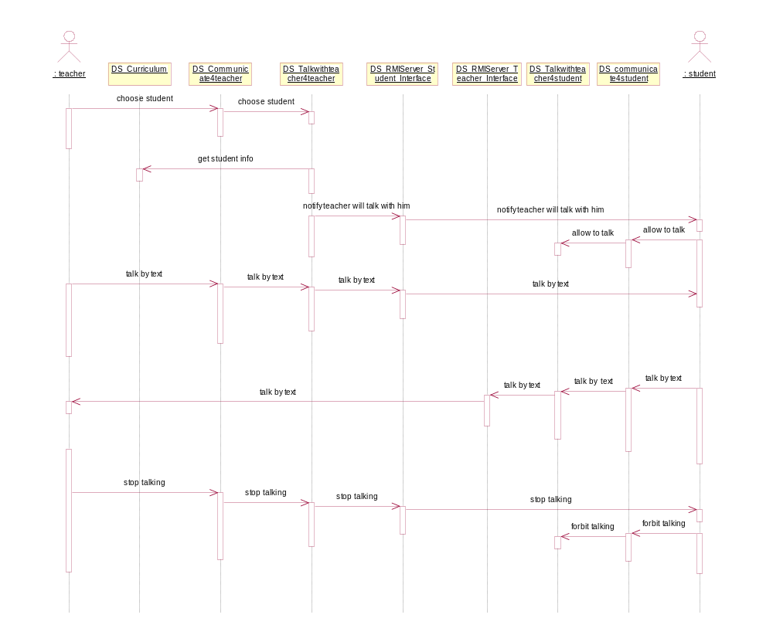

Interaction Diagram - talk with teacher by text

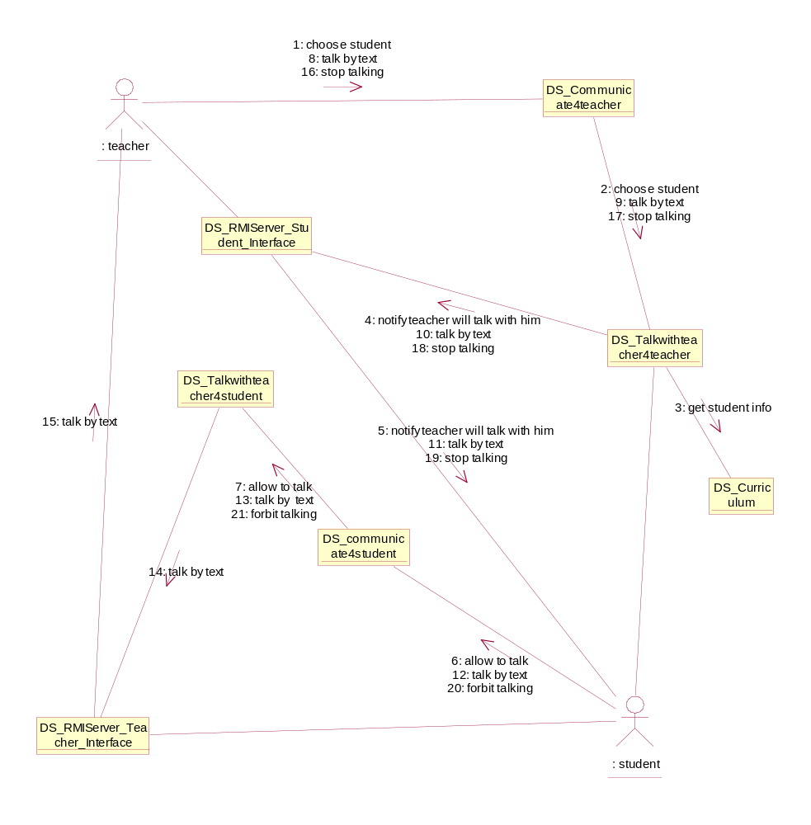

examination

Use Case - browse exam content
Description: Teacher can preview the examination content here.

List of Associations
choose exam content Communicates with browse exam content
browse exam content Communicates with choose exam content

Use Case - browse student group
Description: Teacher can preview student group here.

List of Associations
choose student group Communicates with browse student group
browse student group Communicates with choose student group

Use Case - choose exam content
Description: Teacher can choose examination content here.

List of Associations
choose examination Communicates with choose exam content
choose exam content Communicates with exam start
choose exam content Communicates with browse exam content
browse exam content Communicates with choose exam content

Interaction Diagram - choose exam content

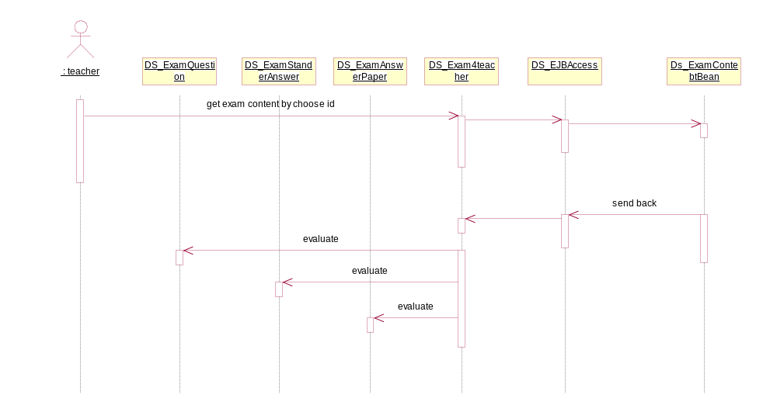

Use Case - choose examination
Description: Teacher can choose examination here.

List of Associations
teacher Communicates with choose examination
choose examination Communicates with choose exam content

Interaction Diagram - choose examination

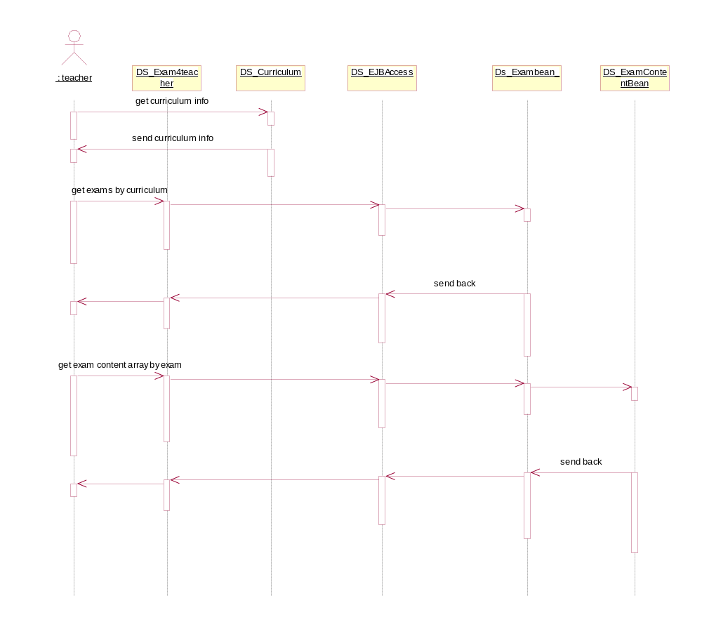

Interaction Diagram - choose examination

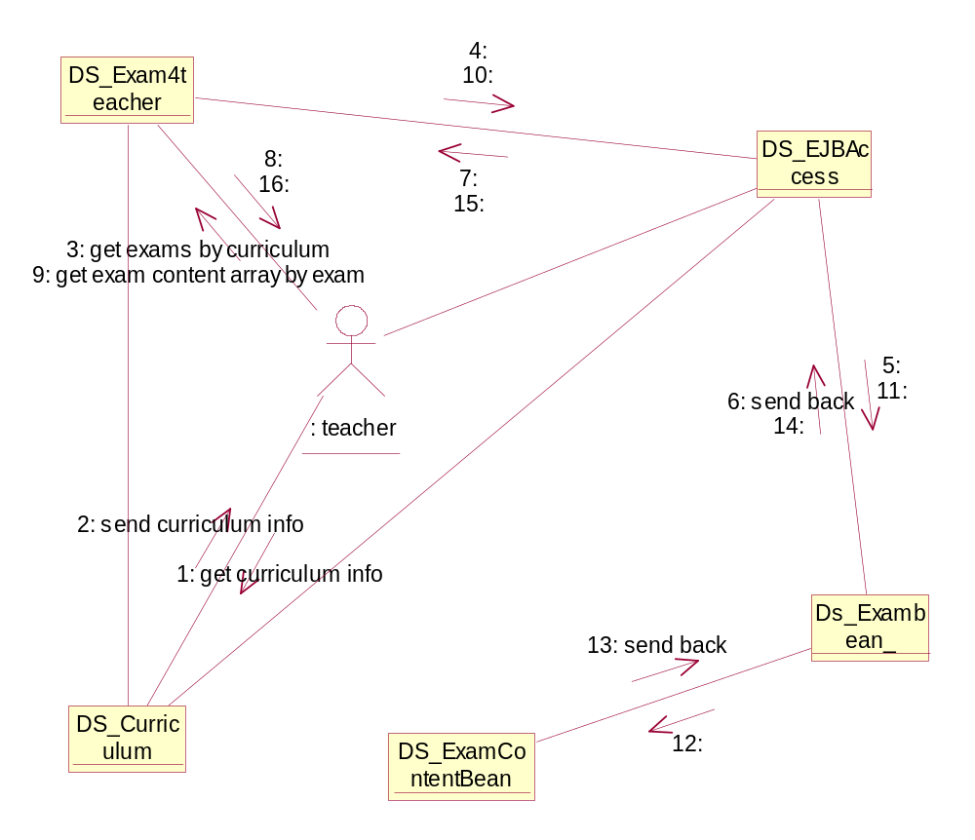

Use Case - choose student group
Description: Teacher can choose student group here.

List of Associations
teacher Communicates with choose student group
choose student group Communicates with exam start
choose student group Communicates with browse student group
browse student group Communicates with choose student group

Interaction Diagram - choose group

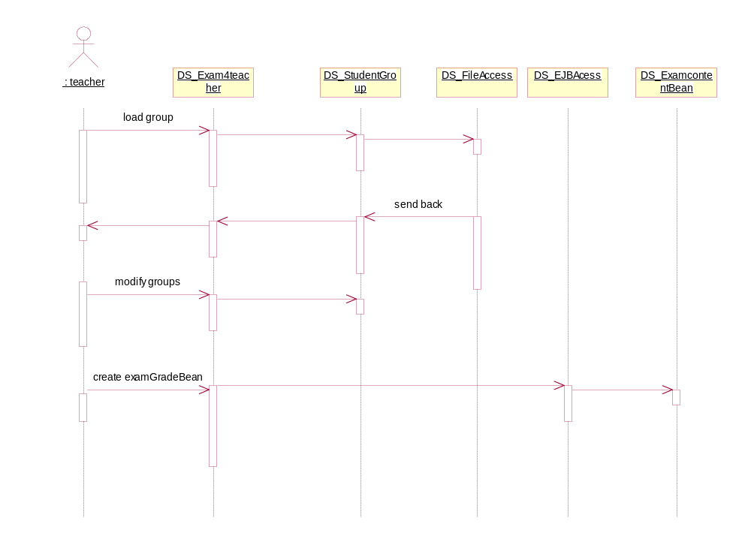

Interaction Diagram - choose group

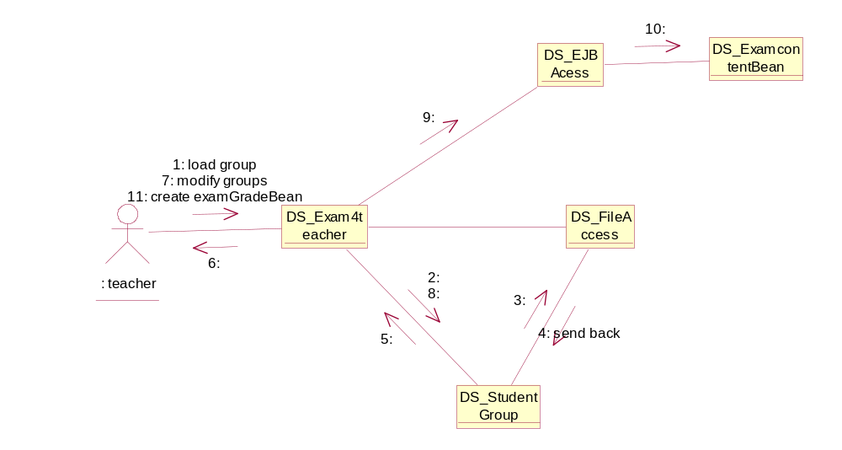

Use Case - exam start
Description: Student open the examination on his/her browser, exam start here.

List of Associations
teacher Communicates with exam start
exam start Communicates with handin by teacher
exam start Communicates with timing start
choose exam content Communicates with exam start
choose student group Communicates with exam start
exam start Communicates with student

Interaction Diagram - examination sending

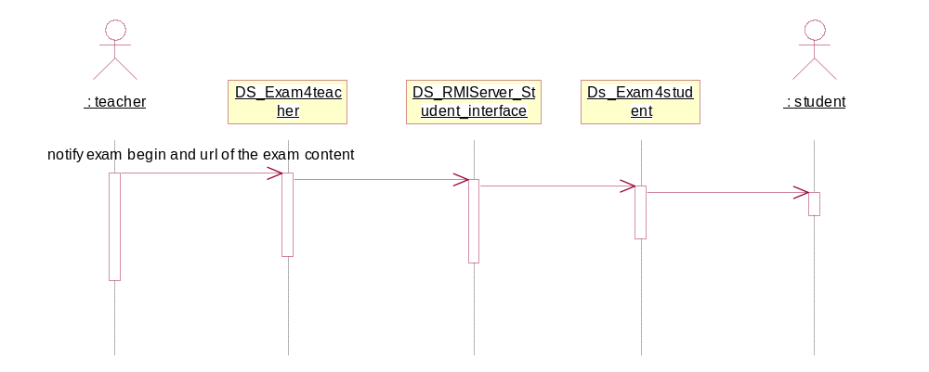

Use Case - handin by teacher
Description; Teacher can hand in the answer paper of students here.

List of Associations
exam start Communicates with handin by teacher
system hand in Communicates with handin by teacher

Interaction Diagram - handin by teacher

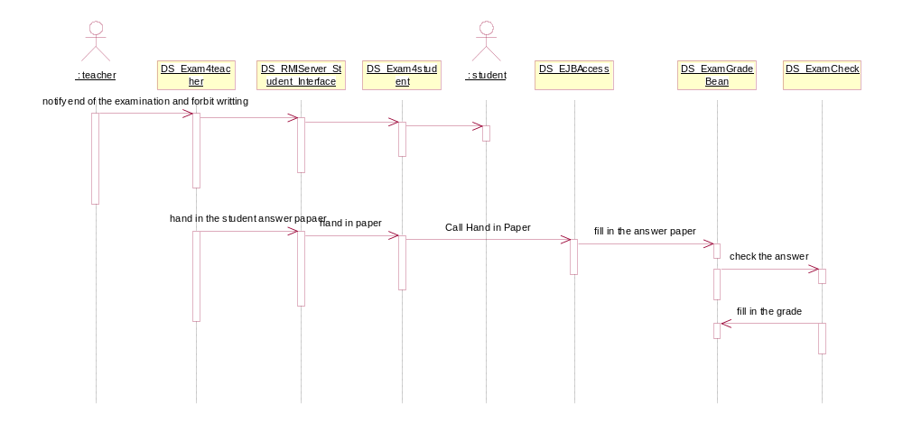

Use Case - save answer paper
Description: Students can save the template answer paper here during the examination.

List of Associations
student get exam content Communicates with save answer paper

Interaction Diagram - save answer paper

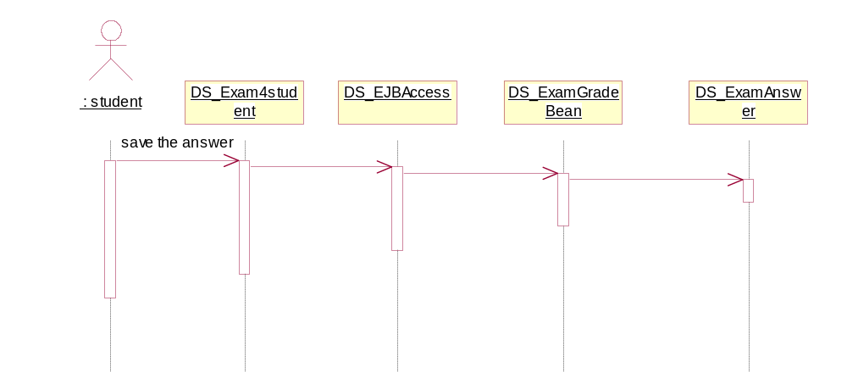

Use Case - student get exam content
Description: Student get the examination question paper and answer paper here.

List of Associations
student Communicates with student get exam content
student get exam content Communicates with student hand in
student get exam content Communicates with save answer paper

Interaction Diagram - get exam content

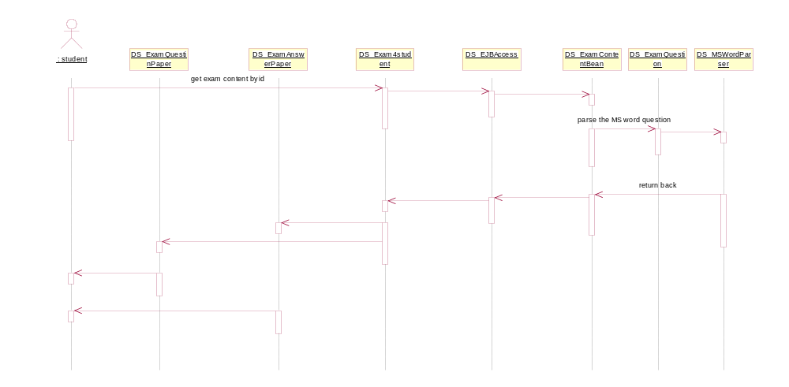

Use Case - student hand in
Description: student hand in his answer paper here.

List of Associations
student Communicates with student hand in
student get exam content Communicates with student hand in

Interaction Diagram - student hand in

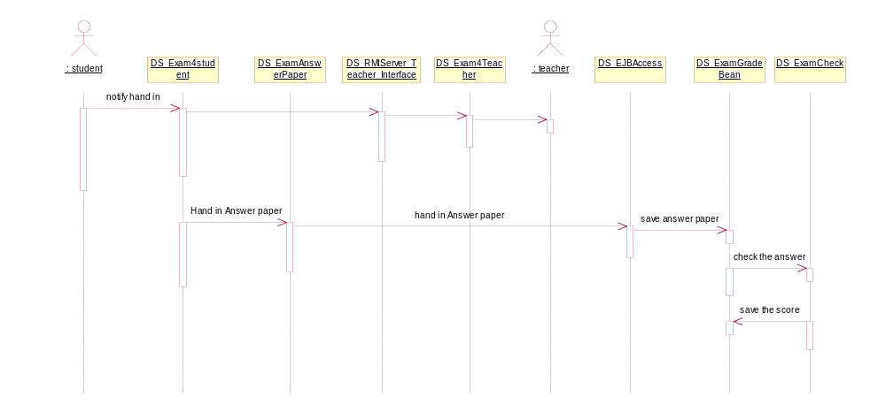

Use Case - system hand in
Description: Time out, system hand in the answer paper of students.

List of Associations
timing start Communicates with system hand in
system hand in Communicates with handin by teacher

Interaction Diagram - system hand in

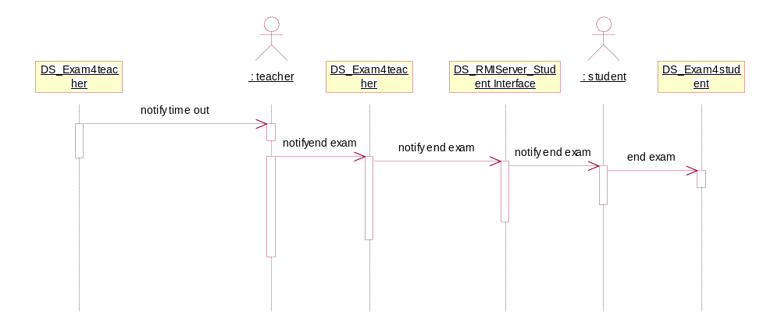

Use Case - timing start
Description: Timing.

List of Associations
exam start Communicates with timing start
timing start Communicates with system hand in

inspection

Use Case - capture screen
Description: Teacher captures the screen of the student.

List of Associations
teacher Communicates with capture screen

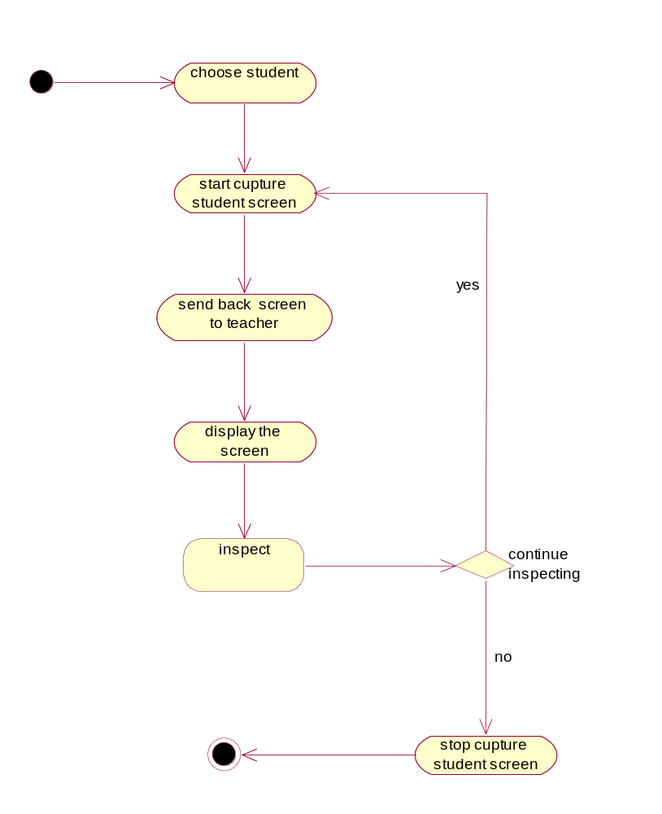

Interaction Diagram - capture screen

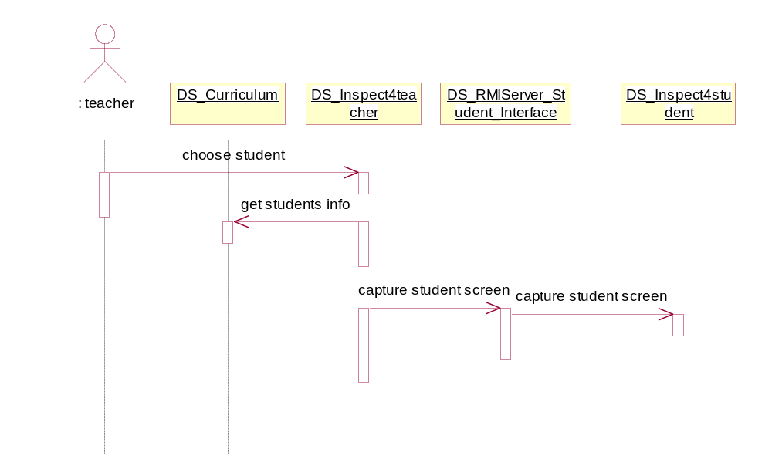

Interaction Diagram - capture screen

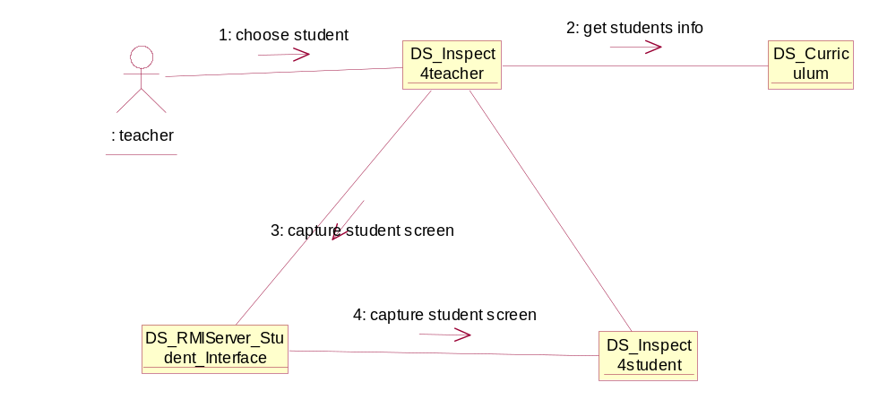

Use Case - dark screen
Description: Teacher dark the screen of the student.

List of Associations
teacher Communicates with dark screen

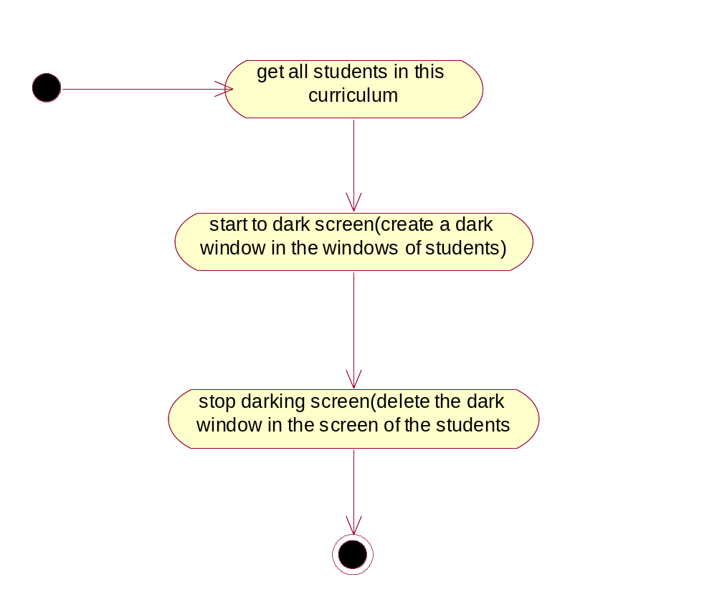

Interaction Diagram - dark screen

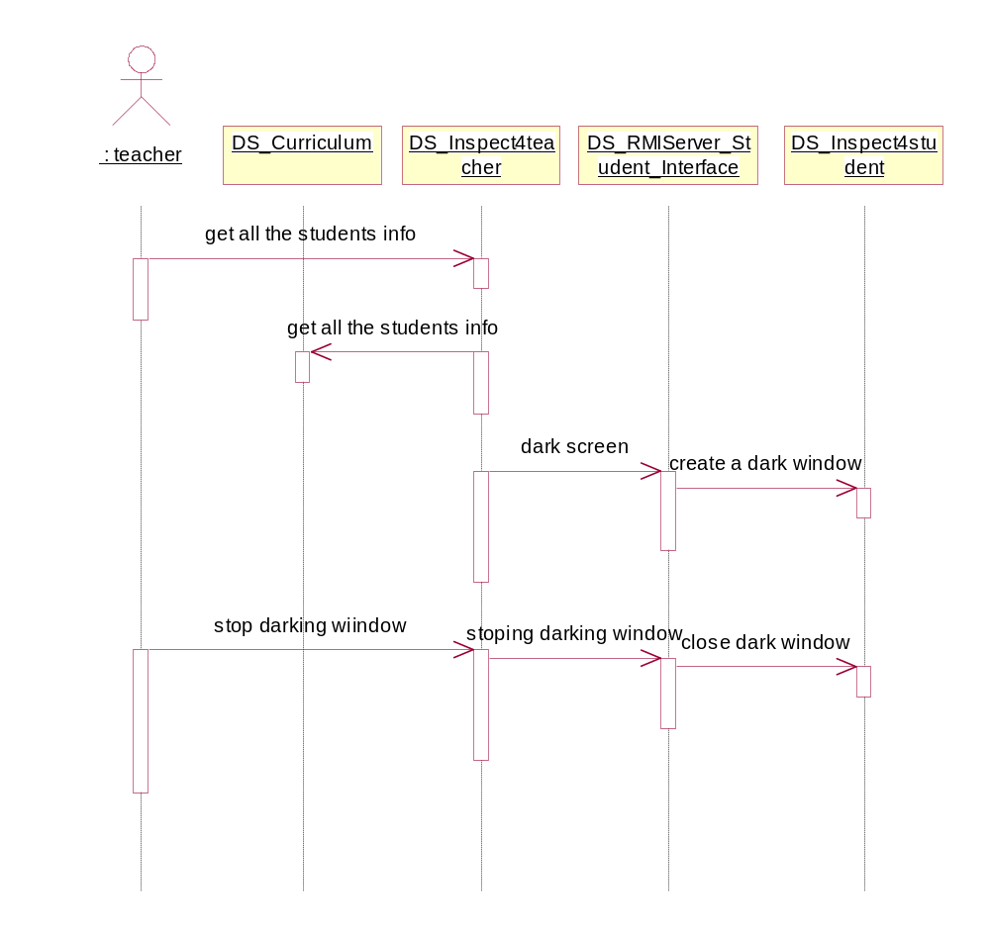

Interaction Diagram - dark screen

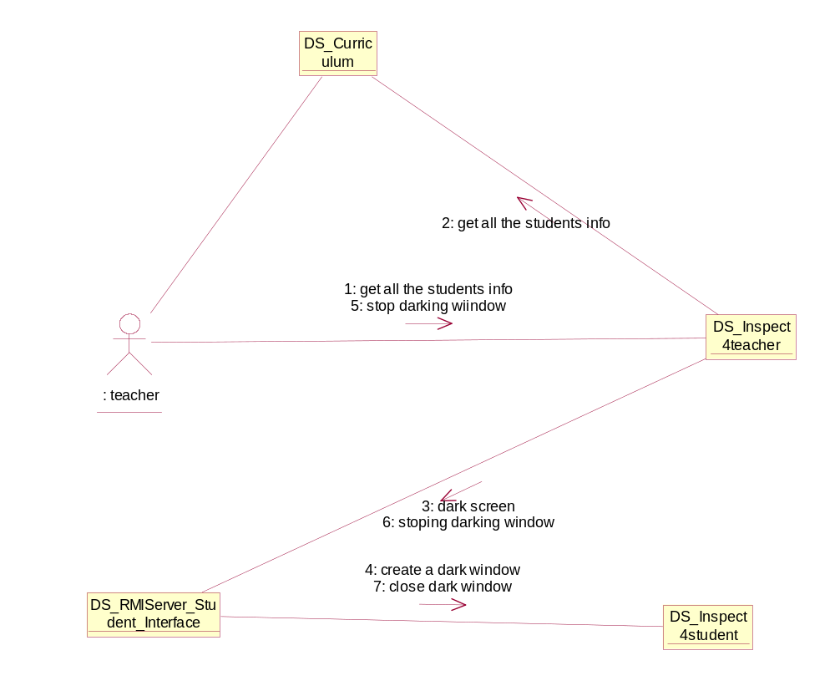

Use Case - warning
Description: Teacher warns the student here.

List of Associations
teacher Communicates with warning

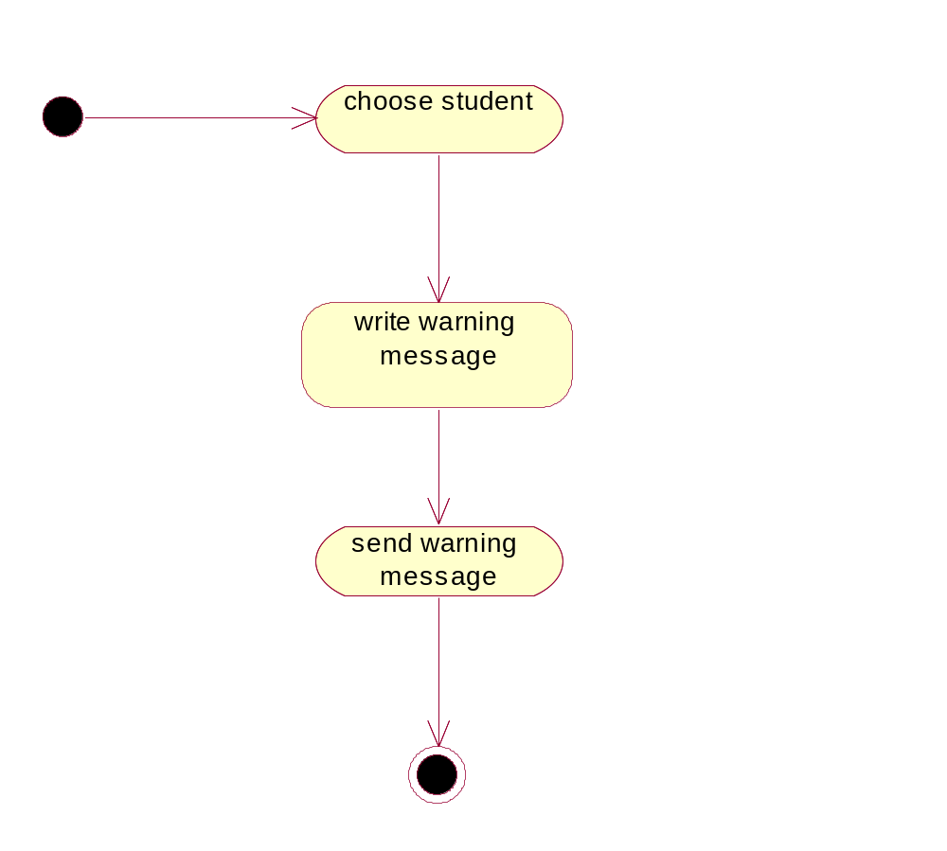

Interaction Diagram - warning

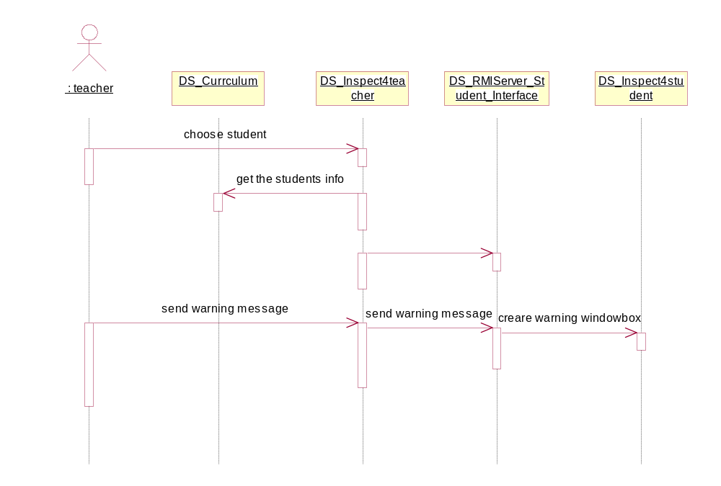

Interaction Diagram - warning

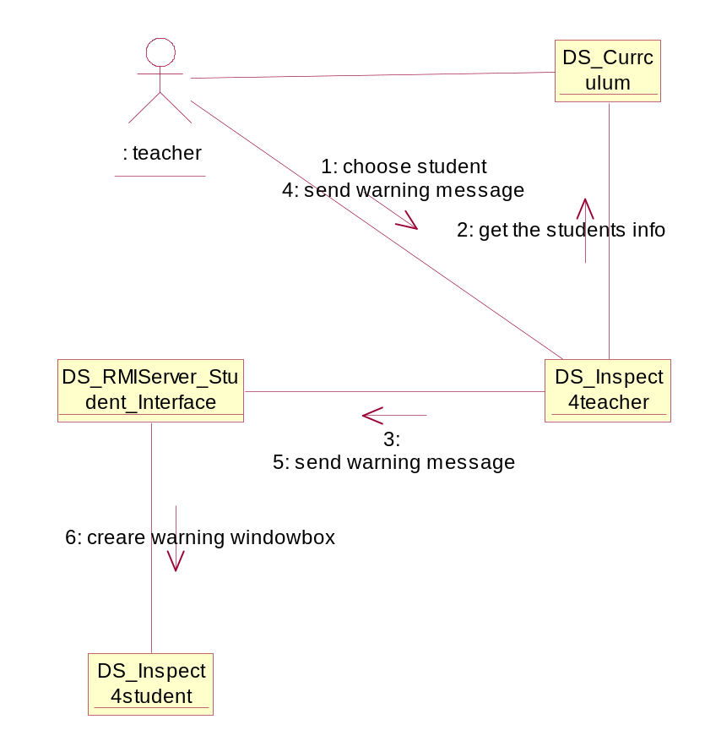

after school

Use Case - attribute (homework,preparation,review,selfexercise,listening) set

Description: Users can query, modify, create or delete the attribute of homework, preparation, review, selfexercise and listening.

List of Associations
homework list4teacher Communicates with attribute (homework, preparation, review, selfexercise, listening) set
preparation list4teacher Communicates with attribute (homework, preparation, review, selfexercise, listening) set
review list4teacher Communicates with attribute (homework, preparation, review, selfexercise, listening) set
selfexercise list4teacher Communicates with attribute (homework, preparation, review, selfexercise, listening) set
listening list4teacher Communicates with attribute (homework, preparation, review, selfexercise, listening) set
attribute (homework, preparation, review, selfexercise, listening) set Communicates with content upload
attribute (homework, preparation, review, selfexercise, listening) set Communicates with select content
attribute (homework, preparation, review, selfexercise, listening) set Communicates with content(homework, preparation, review, elfexercise, listening)list

Interaction Diagram - attribute (homework, preparation, review, selfexercise, listening) set
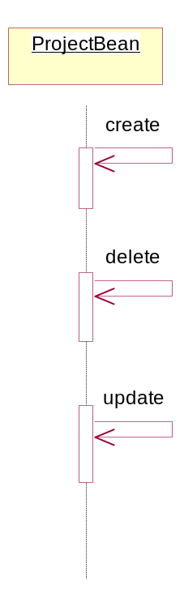

Use Case - check homework
Description: Teacher can check the homework of students.

List of Associations
content(homework,preparation,review,selfexercise,listening)list Communicates with check homework

Interaction Diagram - check homework

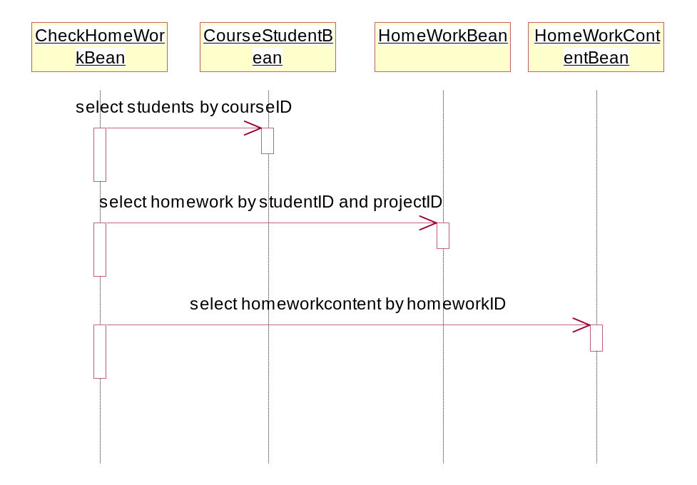

Use Case - checkexam answerpaper
Description: Teacher check the examination answer paper here.

List of Associations
exam content list Communicates with checkexam answerpaper

Interaction Diagram - checkexam answerpaper

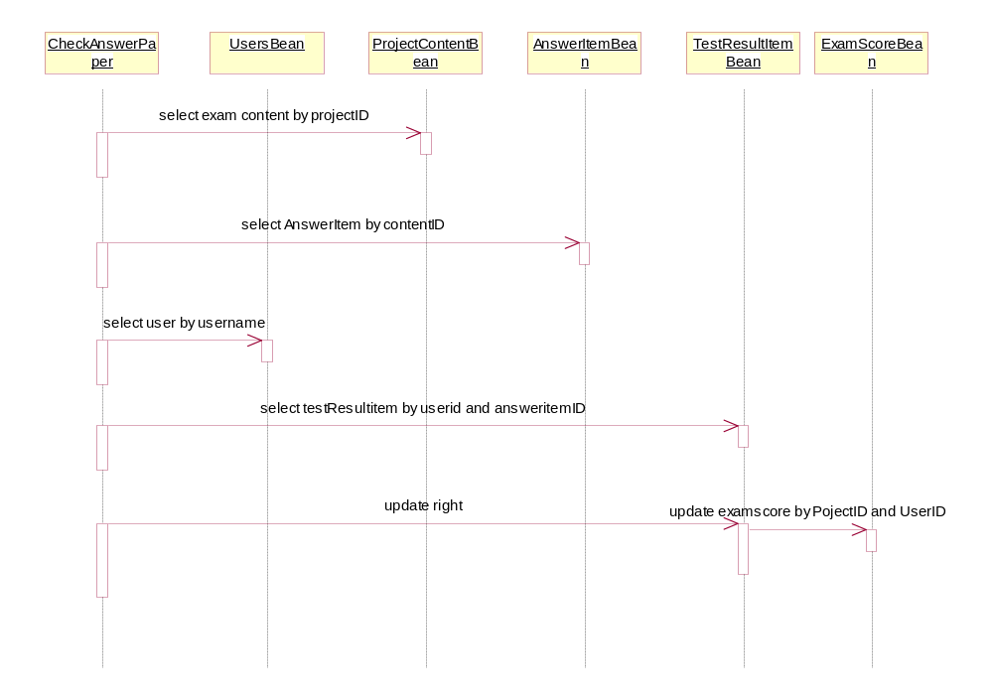

Use Case - content attribute(homework, paraperation, review, selfexercise, listening)4student
Description: Students can query the attribute of homework, paraperation, review, selfexecise, and listening here.

List of Associations
listeninglist4studnet Communicates with content attribute(homework,paraperation,review,selfexercise,listening)4student
selfexerciselist4student Communicates with content attribute(homework,paraperation,review,selfexercise,listening)4student
reviewlist4student Communicates with content attribute(homework,paraperation,review,selfexercise,listening)4student
preparationlist4student Communicates with content attribute(homework,paraperation,review,selfexercise,listening)4student
homeworklist4student Communicates with content attribute(homework,paraperation,review,selfexercise,listening)4student
content attribute(homework,paraperation,review,selfexercise,listening)4student Communicates with contentitemlist4student

Interaction Diagram - content attribute(homework,paraperation,review,selfexercise,listening)4student

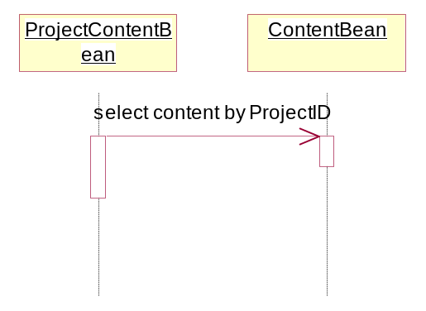

Use Case - content attribute4teacher
Description: teacher can query , modify, create or delete the attribute of Projects

List of Associations
exam content list Communicates with content attribute4teacher
content(homework,preparation,review,selfexercise,listening)list Communicates with content attribute4teacher

Interaction Diagram - ProjectBean

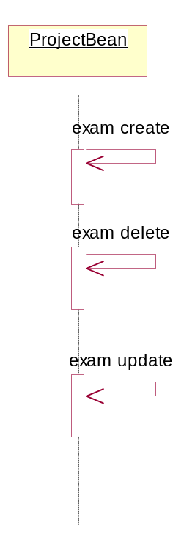

Use Case - content upload
Description: Users can upload content of examination, preparation, review, exercise and listening.

List of Associations
exam attribut set Communicates with content upload
attribute (homework,preparation,review,selfexercise,listening) set Communicates with content upload

Interaction Diagram - content upload

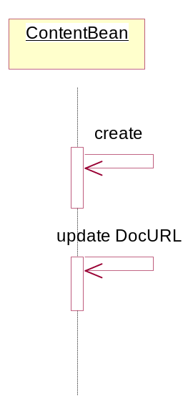

Use Case - content(homework,preparation,review,selfexercise,listening)list
Description: Users can get the list of the contents of homework, preparation, review, selfexercise and listening here.

List of Associations
attribute (homework,preparation,review,selfexercise,listening) set Communicates with content(homework,preparation,review,selfexercise,listening)list
content(homework,preparation,review,selfexercise,listening)list Communicates with content attribute4teacher
content(homework,preparation,review,selfexercise,listening)list Communicates with check homework
content(homework,preparation,review,selfexercise,listening)list Communicates with upload homework after check4teacher
content(homework,preparation,review,selfexercise,listening)list Communicates with student who unfinished homework

Interaction Diagram - content(homework,preparation,review,selfexercise,listening)list

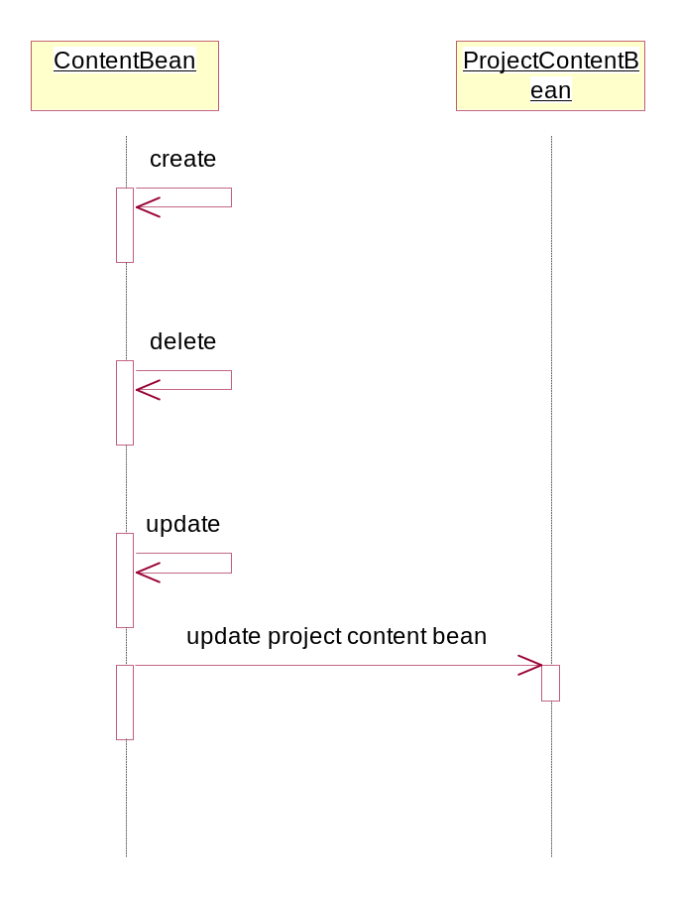

Use Case - contentitemlist4student
Description: Students can get the detail information of contents of the (homework, preparation,…)

List of Associations
content attribute(homework,paraperation,review,selfexercise,listening)4student Communicates with contentitemlist4student

Interaction Diagram - contentitemlist4student

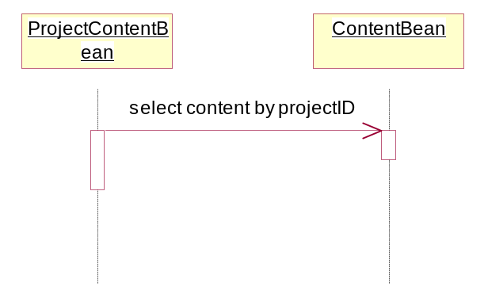

Use Case - curriculum info
Description: Teacher and students can get the curriculum information here.

List of Associations
teacher homepage Communicates with curriculum info
teacher homepage Communicates with curriculum info
student homepageCommunicates with curriculum info

Interaction Diagram - curriculum info

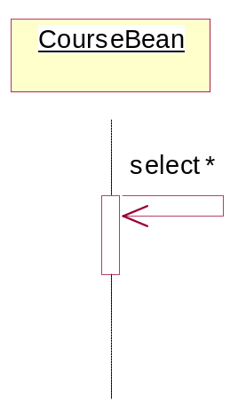

Use Case - exam analysis
Description: Teacher can get exam analysis result here.

List of Associations
exam content list Communicates with exam analysis

Interaction Diagram - exam analysis

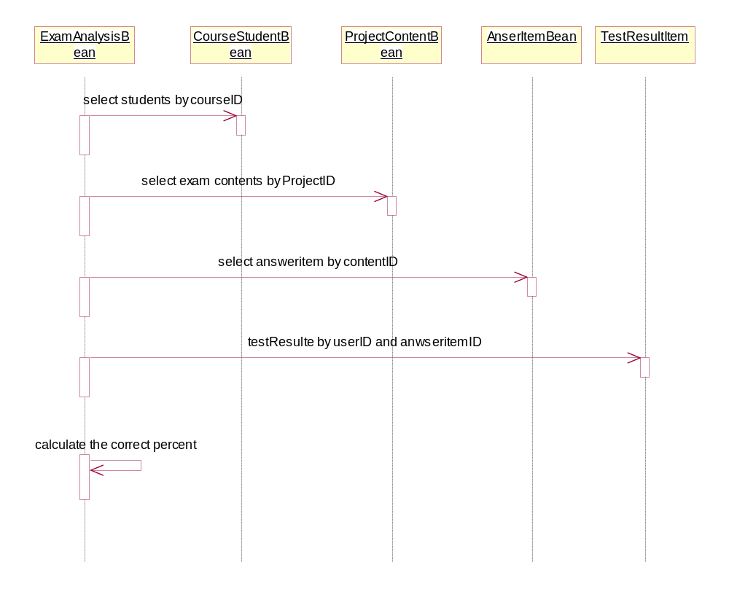

Use Case - exam answerpaper
Description: the exam answer paper will be created, modified, delete and get here.

List of Associations
exam content list Communicates with exam answerpaper

Interaction Diagram - exam answerpaper

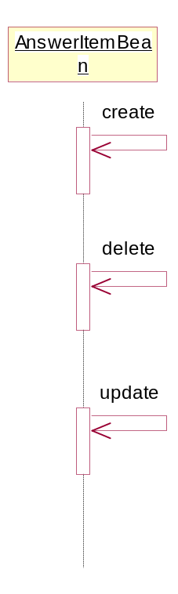

Use Case - exam attribute set
Description: Teacher can create delete and set examination attribute here

List of Associations
examlist4teacher Communicates with exam attribute set
exam attribute set Communicates with exam content list
exam attribute set Communicates with content upload
exam attribute set Communicates with select content

Interaction Diagram - exam attribute set

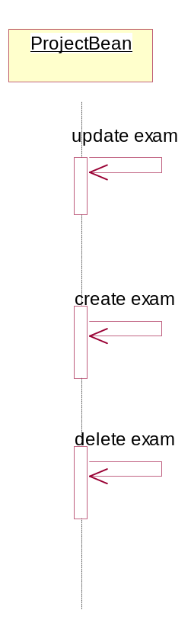

Use Case - exam attribute4student
Description: Students can get the information about the exam attribute.

List of Associations
examlist4student Communicates with exam attribute4student

Use Case - exam content list
Description: Teacher can get exam detail information here. One examination maybe contain several exam contents.

List of Associations
exam attribute set Communicates with exam content list
exam content list Communicates with exam answerpaper
exam content list Communicates with checkexam answerpaper
exam content list Communicates with content attribute4teacher
exam content list Communicates with exam analysis

Interaction Diagram - exam content list

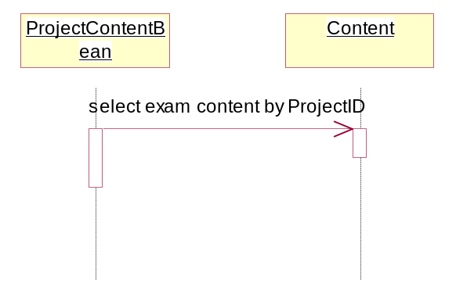

Use Case - examlist4student
Description: Students can get the information of the exam of the curriculums that they attend.

List of Associations
student homepageCommunicates with examlist4student
examlist4student Communicates with exam attribute4student

Interaction Diagram - examlist4student

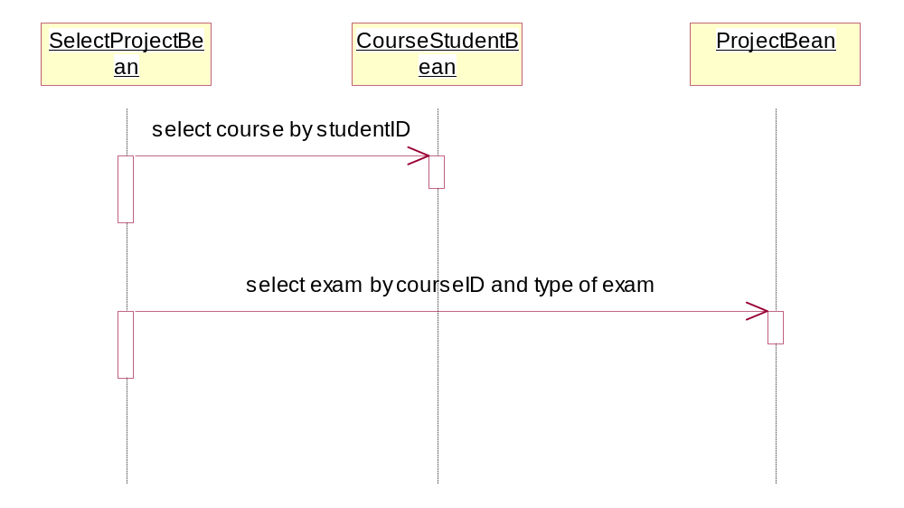

Use Case - examlist4teacher
Description: Teacher can get the information of the exam of the curriculums that they attend.

List of Associations
teacher homepage Communicates with examlist4teacher
examlist4teacher Communicates with exam attribute set

Interaction Diagram - examlist4teacher

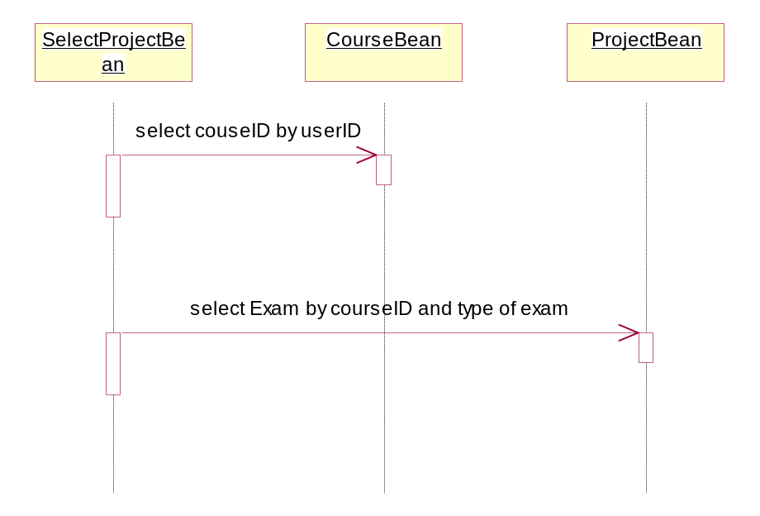

Use Case - homework attibute4student
Description: Student can get detail information about the homework here.

List of Associations
homeworklist4student Communicates with homework attibute4student
homework attibute4student Communicates with homeworkitemlist4student

Interaction Diagram - homework attibute4student

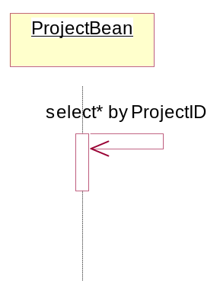

Use Case - homework list4teacher
Description: Teacher can get homework list of the curriculum here.

List of Associations
teacher homepage Communicates with homework list4teacher
homework list4teacher Communicates with attribute (homework,preparation,review,selfexercise,listening) set

Interaction Diagram - homework list4teacher

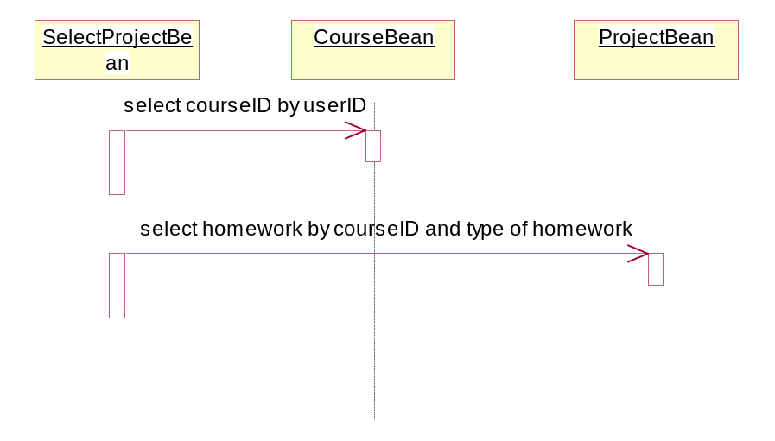

Use Case - homeworkitemlist4student
Description: Student can get the detail of the homework list here.

List of Associations
homework attibute4student Communicates with homeworkitemlist4student
homeworkitemlist4student Communicates with uploadhomework4student

Interaction Diagram - homeworkitemlist4student

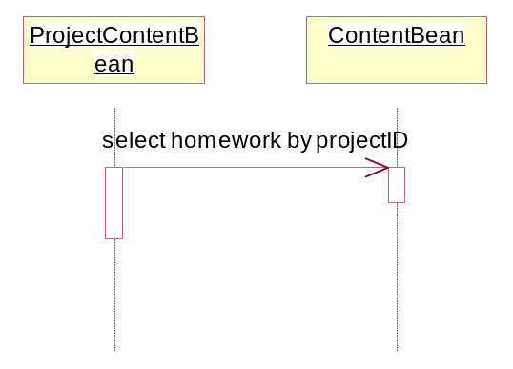

Use Case - homeworklist4student
Description: Students can get the homework list of the curriculum that they attend here.

List of Associations
student homepageCommunicates with homeworklist4student
homeworklist4student Communicates with content attribute(homework,paraperation,review,selfexercise,listening)4student
homeworklist4student Communicates with homework attibute4student

Interaction Diagram - homeworklist4student

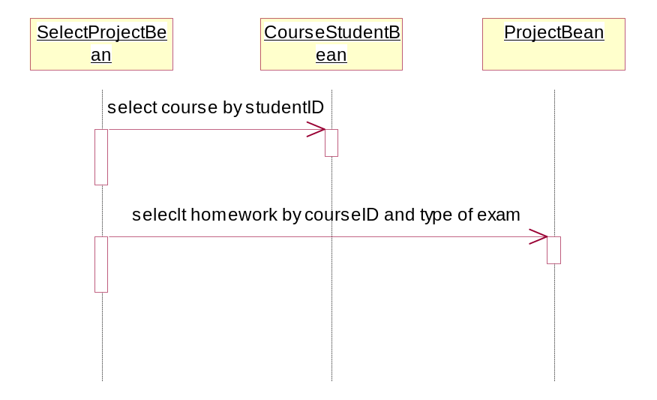

Use Case - listening list4teacher
Description: Teacher can get the listening exercise list here.

List of Associations
teacher homepage Communicates with listening list4teacher
listening list4teacher Communicates with attribute (homework,preparation,review,selfexercise,listening) set

Interaction Diagram - listeninglist 4teacher

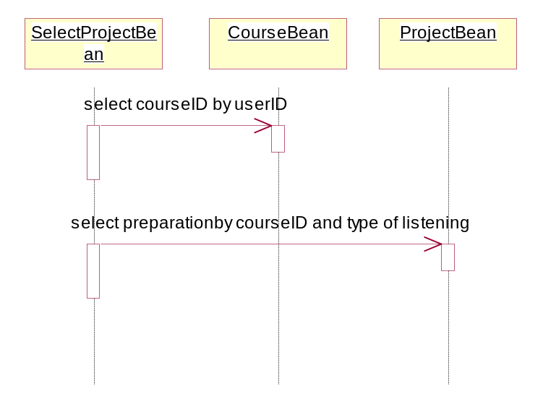

Use Case - listeninglist4studnet
Description: Students can get the listen list that teacher published here.

List of Associations
student homepageCommunicates with listeninglist4studnet
listeninglist4studnet Communicates with content attribute(homework,paraperation,review,selfexercise,listening)4student

Interaction Diagram - listeninglist4studnet

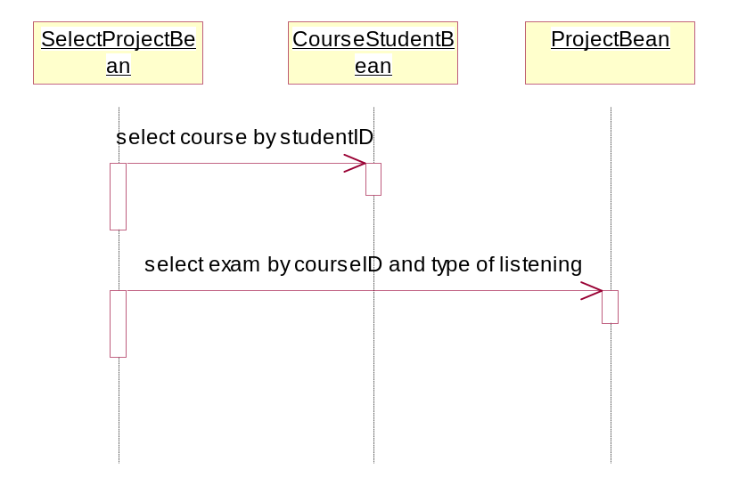

Use Case - preparation list4teacher
Description: Teacher can get the preparation list that teacher published.

List of Associations
teacher homepage Communicates with preparation list4teacher
preparation list4teacher Communicates with attribute (homework,preparation,review,selfexercise,listening) set

Interaction Diagram - preparation list4teacher

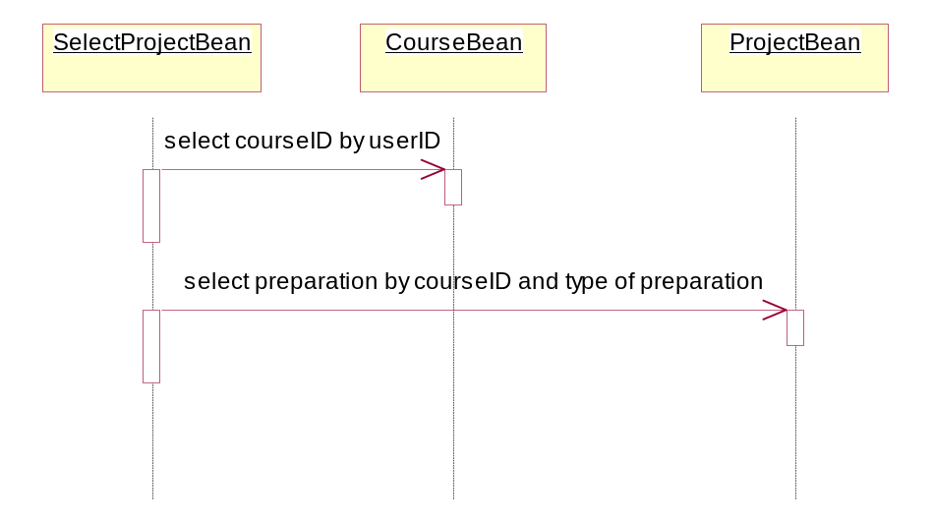

Use Case - preparationlist4student
Description: Students can get the preparation list that teacher published.

List of Associations
student homepageCommunicates with preparationlist4student
preparationlist4student Communicates with content attribute(homework,paraperation,review,selfexercise,listening)4student

Interaction Diagram - preparationlist4student

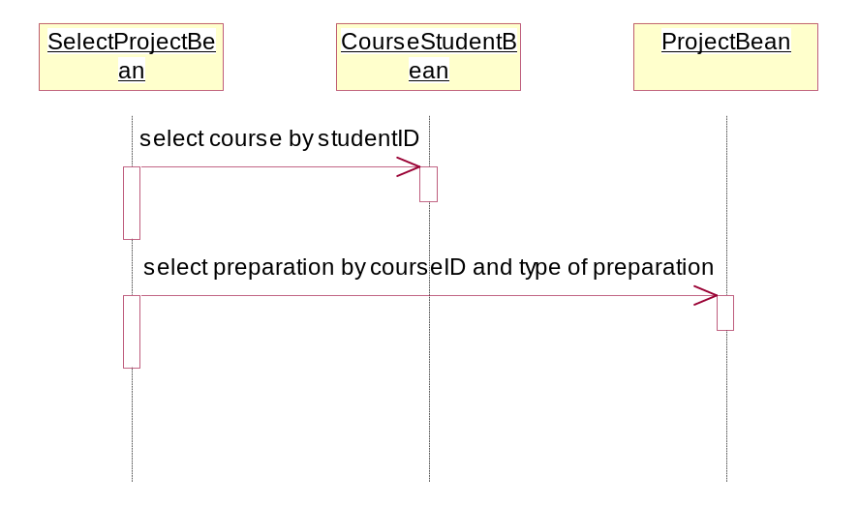

Use Case - registry
Description: it controls the registry of users here.

List of Associations
teacher Communicates with registry
registry Communicates with teacher homepage
student Communicates with registry
registry Communicates with student homepage4teacher

Interaction Diagram - registry

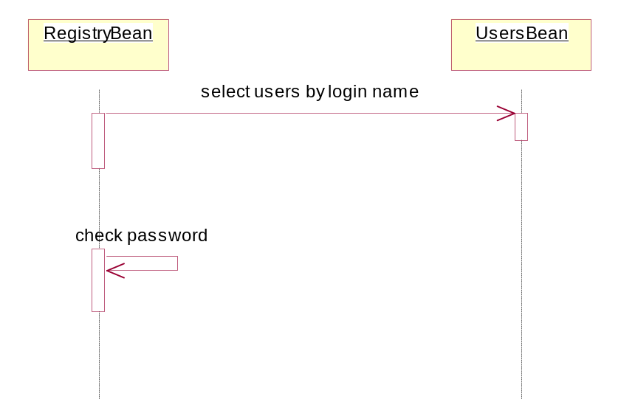

Use Case - review list4teacher
Description: Teacher can get review list here.

List of Associations
teacher homepage Communicates with review list4teacher
review list4teacher Communicates with attribute (homework,preparation,review,selfexercise,listening) set

Interaction Diagram - reviewlist4teacher

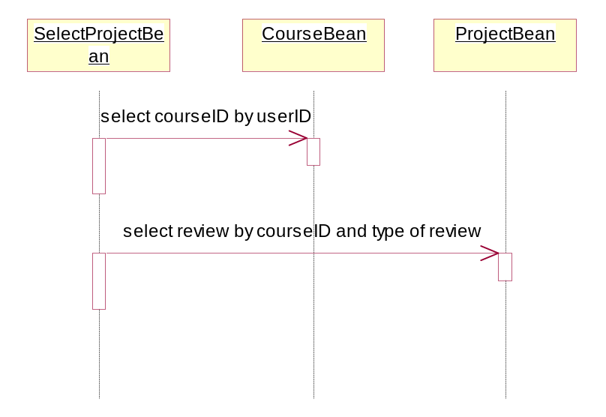

Use Case - reviewlist4student
Description: Student can get the review list here.

List of Associations
student homepageCommunicates with reviewlist4student
reviewlist4student Communicates with content attribute(homework,paraperation,review,selfexercise,listening)4student

Interaction Diagram - reviewlist4student

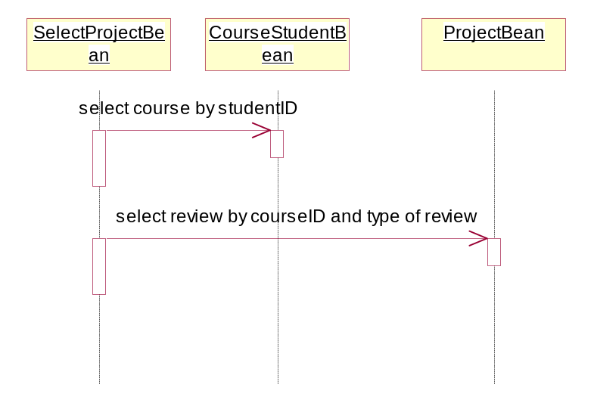

Use Case - search school data
Description: Teacher and Student can query the resource of school.

List of Associations
teacher homepage Communicates with search school data
teacher homepage Communicates with search school data
student homepageCommunicates with search school data

Interaction Diagram - search school data

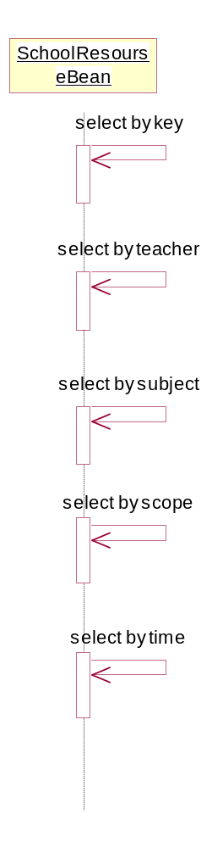

Use Case - search score4student
Description: Student can query the exam score here.

List of Associations
student homepageCommunicates with search score4student

Interaction Diagram - search score4student

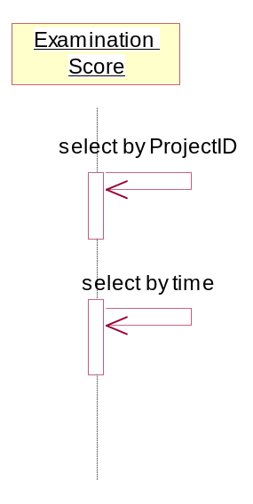

Use Case - search score4teacher
Description: Teacher can query the exam score here.

List of Associations
teacher homepage Communicates with search score4teacher
teacher homepage Communicates with search score4teacher

Interaction Diagram - search score for teacher

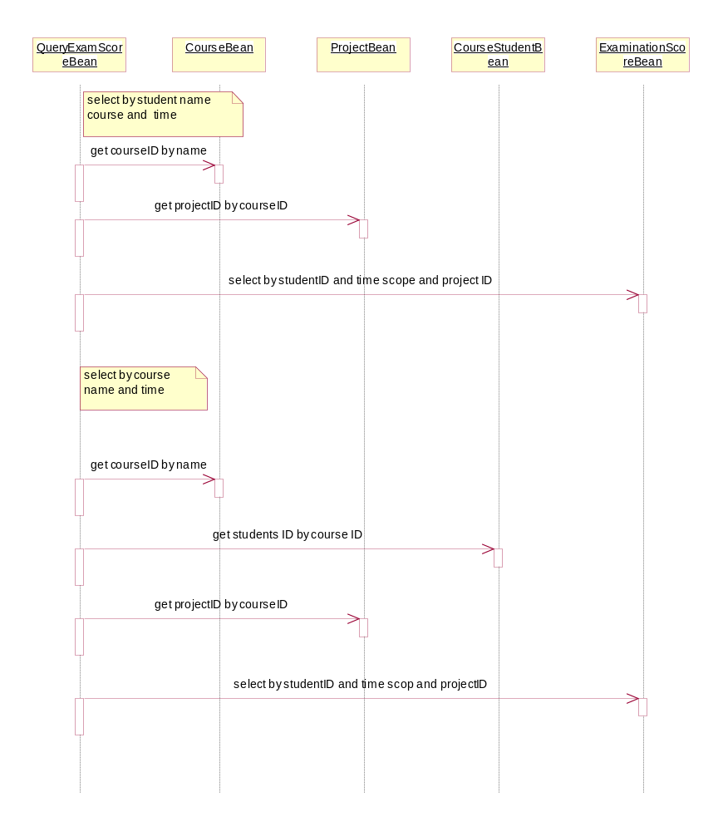

Use Case - select content
Description: Teacher can query the content of (homework, examination, review…) here.

List of Associations
exam attribut set Communicates with select content
attribute (homework,preparation,review,selfexercise,listening) set Communicates with select content

Interaction Diagram - select content

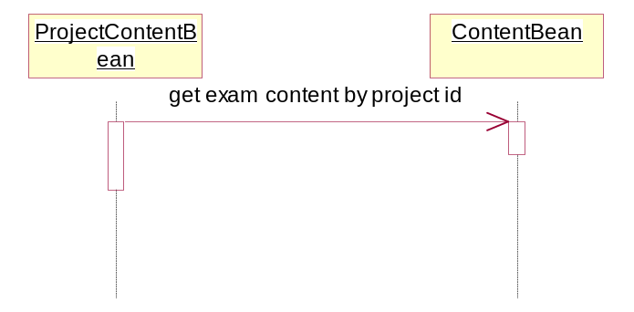

Use Case - self info
Description: Student and teacher can browse and modify their self information here.

List of Associations
student Communicates with self info
teacher homepage Communicates with self info
student homepageCommunicates with self info

Interaction Diagram - self info

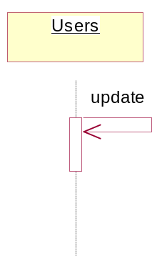

Use Case - selfexercise list4teacher
Description: Teacher can get self exercise list here.

List of Associations
teacher homepage Communicates with selfexercise list4teacher
selfexercise list4teacher Communicates with attribute (homework,preparation,review,selfexercise,listening) set

Interaction Diagram - selfexercise list4teacher

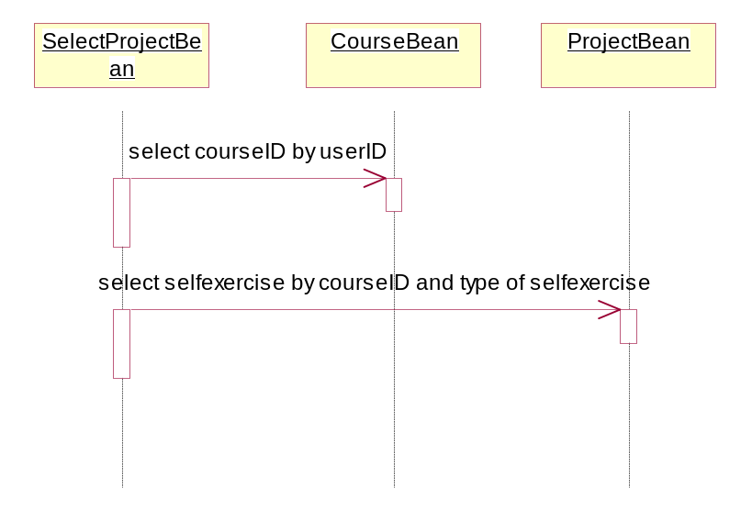

Use Case - selfexerciselist4student
Description: Students can get selfexercise list here.

List of Associations
student homepageCommunicates with selfexerciselist4student
selfexerciselist4student Communicates with content attribute(homework,paraperation,review,selfexercise,listening)4student

Interaction Diagram - selfexerciselist4student

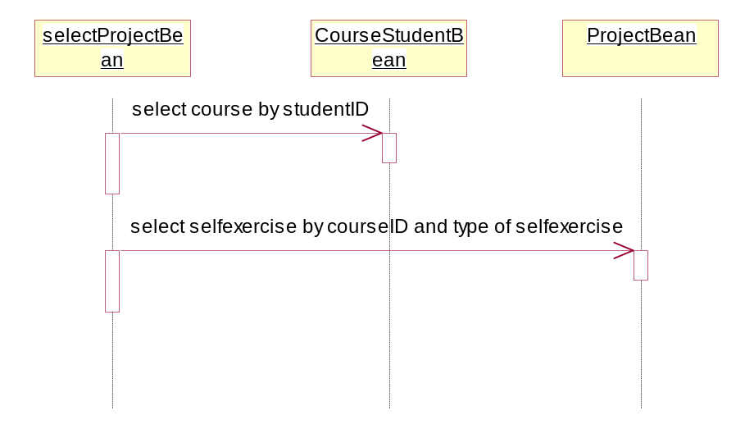

Use Case - student homepage
Description: student can get the all of information that will be appeared in his homepage.

List of Associations
registory Communicates with student homepage
student homepage Communicates with curriculum info
student homepage Communicates with search school data
student homepageCommunicates with self info
student homepager Communicates with examlist4student
student homepageCommunicates with search score4student
student homepageCommunicates with homeworklist4student
student homepageCommunicates with preparationlist4student
student homepageCommunicates with reviewlist4student
student homepageCommunicates with selfexerciselist4student
student homepageCommunicates with listeninglist4studnet

Use Case - student who unfinished homework
Description: Teacher can see the students who not finished the homework.

List of Associations
content(homework,preparation,review,selfexercise,listening)list Communicates with student who unfinished homework

Interaction Diagram - student who unfinished homework

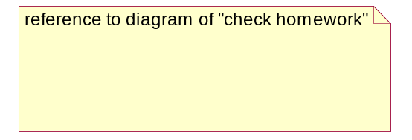

Use Case - teacher homepage
Description: Teacher can get all of information that will be displayed in his homepage.

List of Associations
registry Communicates with teacher homepage
teacher homepage Communicates with curriculum info
teacher homepage Communicates with search school data
teacher homepage Communicates with search score4teacher
teacher homepage Communicates with curriculum info
teacher homepage Communicates with search school data
teacher homepage Communicates with search score4teacher
teacher homepage Communicates with self info
teacher homepage Communicates with examlist4teacher
teacher homepage Communicates with homework list4teacher
teacher homepage Communicates with preparation list4teacher
teacher homepage Communicates with review list4teacher
teacher homepage Communicates with selfexercise list4teacher
teacher homepage Communicates with listening list4teacher

Interaction Diagram - teacher homepage

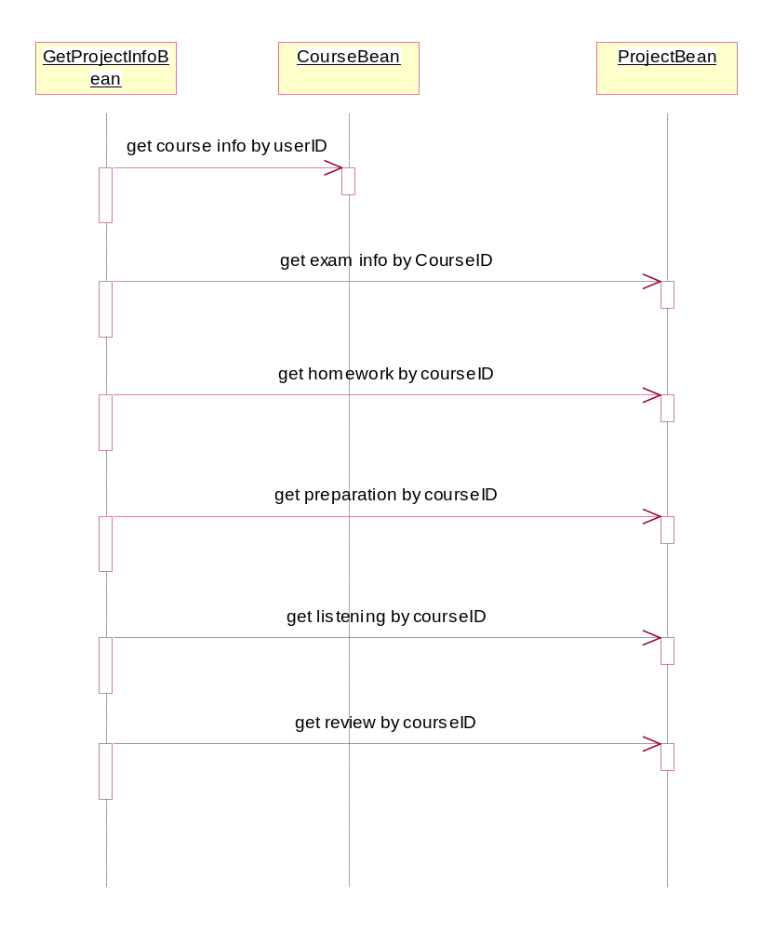

Use Case - upload homework after check4teacher
Description: Teacher can upload the homework of student after he finished check them.

List of Associations
content(homework,preparation,review,selfexercise,listening)list Communicates with upload homework after check4teacher

Interaction Diagram - upload homework after check4teacher

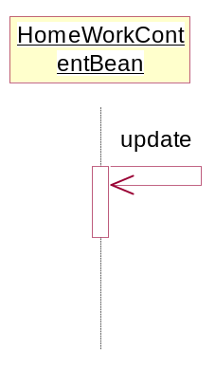

Use Case - uploadhomework4student
Description: Student can upload the homework after he finished them.

List of Associations
homeworkitemlist4student Communicates with uploadhomework4student

Interaction Diagram - uploadhomework4student

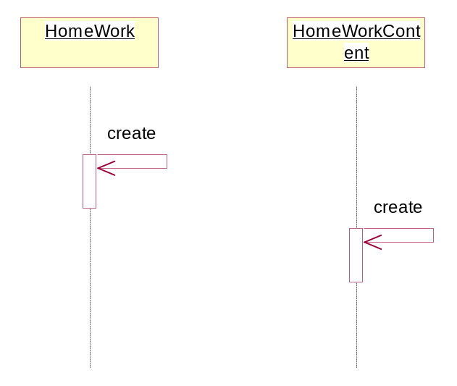

WebService

Use Case - BBS

List of Associations
teacher Communicates with BBS
student Communicates with BBS

Use Case - WebMail

List of Associations
teacher Communicates with WebMail
student Communicates with WebMail

Use Case - chatRoom

List of Associations
teacher Communicates with chatRoom
student Communicates with chatRoom

system management

Use Case - curricular management
Description: System management performs curricular management here.

List of Associations
systemmanager Communicates with curricular management

Use Case - material management
Description: System manager performs projects contents management here.

List of Associations
systemmanager Communicates with material management

Use Case - privilege management
Description: System manage performs the privilege management here.

List of Associations
systemmanager Communicates with privilege management

Interaction Diagram - priviliege management

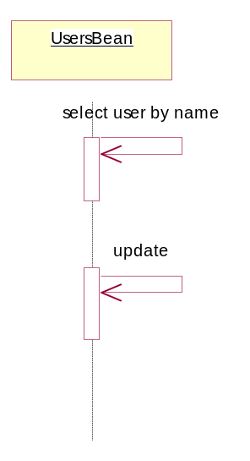

Use Case - student management
Description: System manager performs students’ management here.

List of Associations
systemmanager Communicates with student management

Use Case - teacher management
Description: System manager performs teacher’s management here.

List of Associations
systemmanager Communicates with teacher management

Logical View

Overview
[This subsection describes the overall decomposition of the design model in terms of its package hierarchy and layers.]

根据需求分析及技术分析，将系统分成三大部份：课堂教学部分，课外教学部分与附加网页系统。
课堂教学部分包括：在线考试，课堂交流，监视监听，座次考勤四个子系统；
课外教学部分包括：考试准备，自习系统，后台管理三个子系统；
附加网页系统包括：BBS，聊天室，WebMail服务三个子系统。

课堂教学部分: 面向use case 的设计方案，即全部对象可分为两大类----实体对象（如，教师，学生，
课程，试题），功能对象（如,考试，课堂交流，监视监听，座次考勤）复杂的功能对象可以包含子功能对象（如课堂交流可以包含演示，分组交流，师生对话等）
RMIServer_Interface 提供全部的远程过程调用，EJBAccess 提供全部的EJB调用，JMFSenderAndPlayer 实现全部的媒体流交互。
教师对象与学生对象为GUI数据与功能调用的接口。如：教师对象包含课程，考试，课堂交流等对象。
如GUI 需要该教师的课程信息：GUI→DS_Teacher→DS_Curriculum
如GUI 需要教师执行分组交流功能：GUI->DS_Teacher->DS_Communicate->DS_GroupTalk
课外教学部分：利用J2EE标准框架结构。

Architecturally Significant Design Packages

5.2.1课堂教学部分
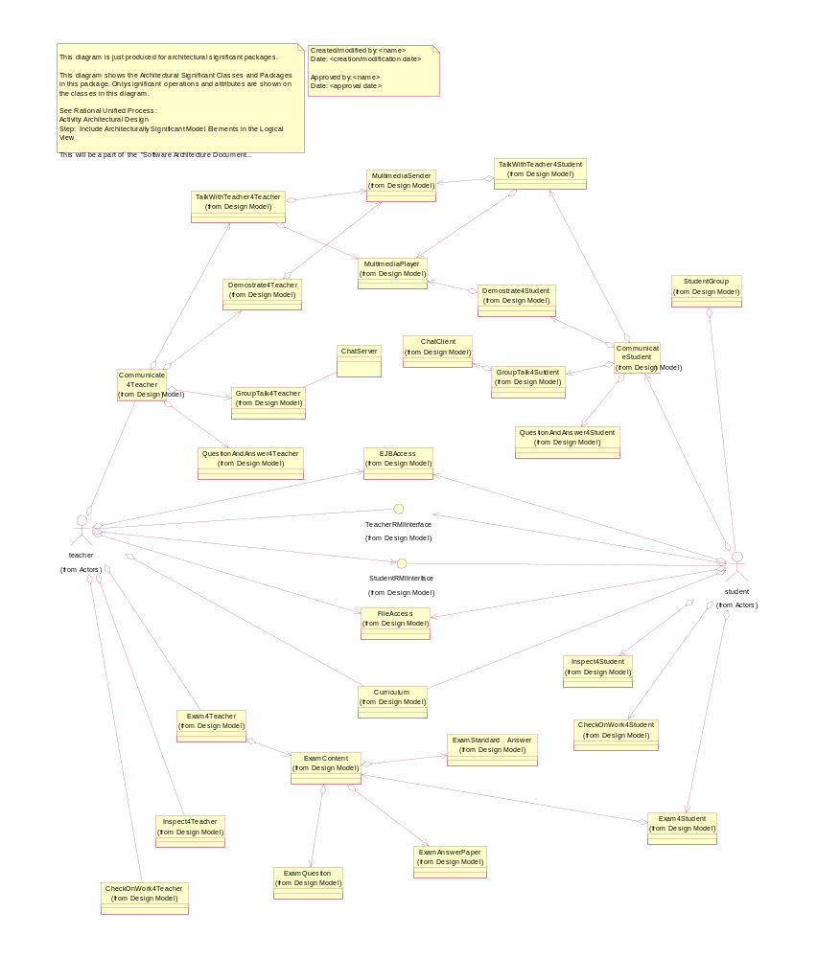

部分Objects and Interface 列表:
DS_RMIServer_Teacher_Interface
DS_RMIServer_Student_Interface:
DS_EJBAccess
DS_FileAccess

DS_Teacher
DS_Student
DS_StudentGroup
DS_Curriculum

DS_Exam
DS_Communicate
DS_Inspect
DS_CheckOnWorkAttendance

DS_TalkWithTeacher
DS_Demostrate
DS_GroupTalk
DS_QuestionAndAnswer

DS_ExamContent
DS_Question
DS_AnswerPaper
DS_StandardAnswer

其它Package
JMF DispatcherAndPlayer:
TextCommunicaion:
DS_EJBAccess
RecorderAndPlayer:
DS_GUI_Classroom:

（NOTE）:
- 这里罗列的objects 只包含系统全部的功能需求，而不是开发中的全部objects. 举例：DS_Communicate 位课堂交流操作对象，在详细设计中因教师与学生的需求不同可以派生为 DS_Communicate4Teacher 和 DS_Communicate4Student;
- 这里的其它Packages 表示将尽可能的利用现成的JAR包，进行改造后嵌入本系统，因此没有做详细说明
- DS_GUI_Classroom Package从Implementation view 图1看既为教师的teacher interface 和学生的student interface 层. 该设计可参看UI DESIGN 文档，将在今后或开发过程中补全
- 课堂教学部分的EJB 与课外教学公用，这里不作描述，可参照课外教学部分

部分Objects 说明：

DS_RMIServer_Teacher_Interface
Description:
由DS_Teacher实现的远程调用接口，DS_Student 可以通过此接口向DS_Teacher发送消息或控制教师界面。从Implementation view 图1看既为教师NetWorkLevel 中的RMIServerLevel 层
Functions:
- notifyHandinStudent: DS_Student 通过此方法通知DS_Teacher上交试卷;
- notifyAnswerQuestion: DS_Student 通过此方法向DS_Teacher 提问或回答（此功能可由 JMF disptcherAndPlayer and TextCommunication 完成）
- notifyRaiseHand: DS_Student 通过此方法向DS_Teacher 举手；
- rspondCalling: DS_Student 通过此方法向DS_Teacher 回应点名
- getStudentGroupInfo: DS_Student 通过此方法向DS_Teacher 获取学生分组信息
- registryClassroom: DS_Student 通过此方法通知DS_Teacher 已经登录教室

DS_RMIServer_Student_Interface
Description:
由DS_Student实现的远程调用接口，DS_Teacher 可以通过此接口向DS_Student发送消息或控制教师界面。从Implementation view 图1看既为学生NetWorkLevel 中的RMIServerLevel 层
Functions:
1. notifyBeginExam: DS_Teacher通过此方法通知DS_Student开始考试;
- notifyEndExam: DS_Teacher通过此方法通知DS_Student 考试结束，并上交试卷；
- notifyInfo: DS_Teacher 通过此方法向DS_Student 发送任意信息；
- notifyBeginListening: DS_Teacher 通过此方法通知DS_Student 开始听力练习；
- notifyBeginQuestion: DS_Teacher 通过此方法通知DS_Student 开始抢答；
- notifyAllow2Answer: DS_Teacher 通过此方法通知DS_Student 可以发言；
- darkScreen: DS_Teacher 通过此方法使DS_Student 黑屏或停止黑屏；
- warning: DS_Teacher 通过此方法向DS_Student 发出警告；
- calling: DS_Teacher 通过此方法向DS_Student 发出点名；

DS_EJBAccess
Description:
为DS_Student, Ds_Teacher 的EJB 调用提供接口。从Implementation view 图1看既为教师和学生NetWorkLevel 中EJB interface 层(注意这里的interface 不是java conception)

Functions:
1. RegistryOperations: 提供一组方法访问DS_RegistryBean, 包括和对口令等操作；
2.TeacherInfoOperations: 提供一组方法访问DS_TeacherBean, 包括获取，修改，保存等操作；
3. StudentinfoOperations: 提供一组方法访问DS_StudentBean, 包括获取，修改，保存等操作；
4. CurriculumInfoOperations: 提供一组方法访问DS_CurriculumBean, 包括获取，修改，保存等操作；
5. ExamInfoOperations: 提供一组方法访问DS_ExamBean and DS_ExamContentBean 包括获取，保存,提交试卷等操作；
6. ListeningInfoOperations: 提供一组方法访问DS_ListeningBean, 包括获取，修改，保存等操 作；

DS_Teacher
Description:
拥有教师属性特征，为GUI提供实现教师全部功能的接口, 其功能的实现依赖于其它Objects如DS_Exam 和 Package 如 JMF dispatcher and player, TextCommunication. 从Implementation view 图1看既为教师task control level.

Functions:
- RegistryOperations: 提供一组方法登录系统；
- ExamOperations: 提供一组方法实现在线考试（
包括分组（DS_Student_Groups）；
试题的取得，浏览，发送，宣布考试开始；
强行与自动收卷（DS_Exam）；
- ClassroomCommunicationOperations: 提供一组方法实现课堂交流包括
分组交流中的分组操作（DS_Student_Groups），语音，文字交谈（DS_Communicate）加入离开某组；
点对点，点对多语音通话(DS_Communicate)；
录音，停止录音，录音回放（ReCorderAndPlayer）;
提问（语音与文字），显示举手，选择允许回答(DS_Communicate)
抢答(DS_Communicate)
演示屏幕（JMF DispatcherAndPlayer:）
- ListeningExcercise: 提供一组方法实现课堂听力练习（RecorderAndPlayer）
提示准备开始，播放听力，终止播放；
- InspectOperations: 提供一组方法实现课堂监视监听(DS_Inspect)
获取学生窗口，关闭监视窗口（JMF）;
黑屏；（DS_RMIServer_Student_Interface）
警告；(DS_RMIServer_Student_Interface)
- CheckOnworkAttendanceOperations: 提供一组方法实现课堂座次考勤(DS_CheckOnWorkAttendance)
各种分组操作:分组，互换，加旁听，删旁听，查看座位，调入座位，保存座位（DS_StudentGroup）
点名：(DS_RMIServer_Student_Interface)
获取课堂信息与登录信息：
浏览学生个人信息；
浏览修改教师个人信息；

DS_Student
Description:
拥有学生属性特征，为GUI提供实现学生全部功能的接口, 其功能的实现依赖于其它Objects如DS_Exam 和 Package 如 JMF dispatcher and player, TextCommunication. 从Implementation view 图1看既为学生task control level.

Functions:
- RegistryOperations: 提供一组方法登录系统；
- ExamOperations: 提供一组方法实现在线考试（DS_Exam）
包括考试开始，试题的取得，；
保存答题，时间显示；
主动与自动收卷；
- classroomCommunicationOperations: 提供一组方法实现课堂交流包括
分组交流中的分组信息获取（DS_Student_Groups），语音，文字交谈（DS_Communicate）
点对点，点对多语音通话(DS_Communicate)；
录音，停止录音，录音回放（ReCorderAndPlayer）;
提问（语音与文字），举手，回答(DS_Communicate)
抢答(DS_Communicate)
- ListeningExcercise: 提供一组方法实现课堂听力练习（RecorderAndPlayer）
提示准备开始，播放听力，终止播放；
- InspectOperations: 提供一组方法实现课堂监视监听(DS_Inspect)
截取窗口，发送窗口，停止发送（JMF）;
黑屏；（DS_RMIServer_Student_Interface）
警告；(DS_RMIServer_Student_Interface)
- CheckOnworkAttendanceOperations: 提供一组方法实现课堂座次考勤(DS_CheckOnWorkAttendance)
各种分组操作:分组，互换，加旁听，删旁听，查看座位，调入座位，保存座位（DS_StudentGroup）
回应点名：(DS_RMIServer_Teacher_Interface)
获取课堂信息：
浏览学生个人信息；

DS_StudentGroup
Description:
拥有分组信息，提供分组管理操作的各种实现；

Functions:
- randomGroup: 随机/快速分组
- exachangeTwoStudents: 交换不同组俩学生座位
- appendAudit：添加旁听
- removeAudit: 删除旁听
- getGroupInfo: 获取分组信息
- SaveGroupInfo: 保存分组信息

DS_Curriculum
Description:
拥有课程信息，提供课程信息查询操作的各种实现：

Functions:
- getTeacherInfo: 获取该课程教师信息
- getStudentsInfo: 获取该课程学生信息
- getCourseInfo: 获取该课程信息

DS_Exam
Description:
拥有考试信息，提供在线考试操作的各种实现；

Functions:
- groupOperations: 教师考试分组（DS_StudentGroup）
- getExamContent: 教师试题浏览 （DS_EJBAccess）
- dispatchOperations: 教师发送试题（DS_RMIServer_Student_Interface, DS_EJBAccess）
- notifyHandinStudent: 教师显示上交考卷的学生（DS_RMIServer_Teacher_Interface
- endExamination: 教师收取单个或全部学生试卷（DS_RMIServer_Student_Interface, DS_EJBAccess）
- startExamination: 学生开始考试（DS_RMIServer_Student_Interface）
- getExamContents: 学生获取考题及答题纸（DS_EJBAccess）
- saveExamAnswer: 学生保存答题纸内容（DS_EJBAccess）
- timeDisplay: 显示答题时间

DS_Communicate
Description:
实现课堂交流操作的全部功能：

Function:
1. groupOperations: 教师课堂交流分组（DS_StudentGroup）
- AudioCommunication: 点对点，点对多通话（JFM）
- TextCommunication: 文字交流（TextCommunicaion:）
- Audio record and play operations: 启动录音，停止录音，录音回放（RecorderAndPlayer）
- Video play operations: 启动vod，停止录音vod（RecorderAndPlayer）
- question and answer operations: 提问，举手，抢答，允许回答，回答。

DS_Inspect
Description:
实现课堂监视监听操作的全部功能；

Functions:
获取学生窗口，关闭监视窗口（JMF）;
黑屏；停止黑屏（DS_RMIServer_Student_Interface）
警告；(DS_RMIServer_Student_Interface)
截取窗口，发送窗口，停止发送（JMF）;

DS_CheckOnWorkAttendance
Description:
实现课堂座次考勤操作的全部功能：

Function:
- groupOperations: 教师课堂交流分组（DS_StudentGroup）
- callingOperations: 教师点名与学生回应
- studentInfoOperations: 学生信息浏览与修改；
- teacherInfoOperations: 教师信息浏览与修改；

其它Package 说明：

JMF DispatcherAndPlayer
Description:
利用java jmf package 提供的API，实现媒体（包括声音与图像）流的传输：
Objects:
DS_DataSource: 实现媒体流数据源（包括抓屏，录音，多媒体等）
DS_MediaCompressUncompress: 实现媒体流数据源的压缩与解压缩
DS_MediaSentor: 实现媒体流传输（包括点对点，广播等）
DS_MediaPlayer: 实现媒体流的接收与播放

TextCommunicaion
Description:
实现聊天室功能;

RecorderAndPlayer
Description:
实现Audio 的录制与播放功能

DS_GUI_Classroom
Description:
实现UI DESIGN的用户界面

2课外教学部分

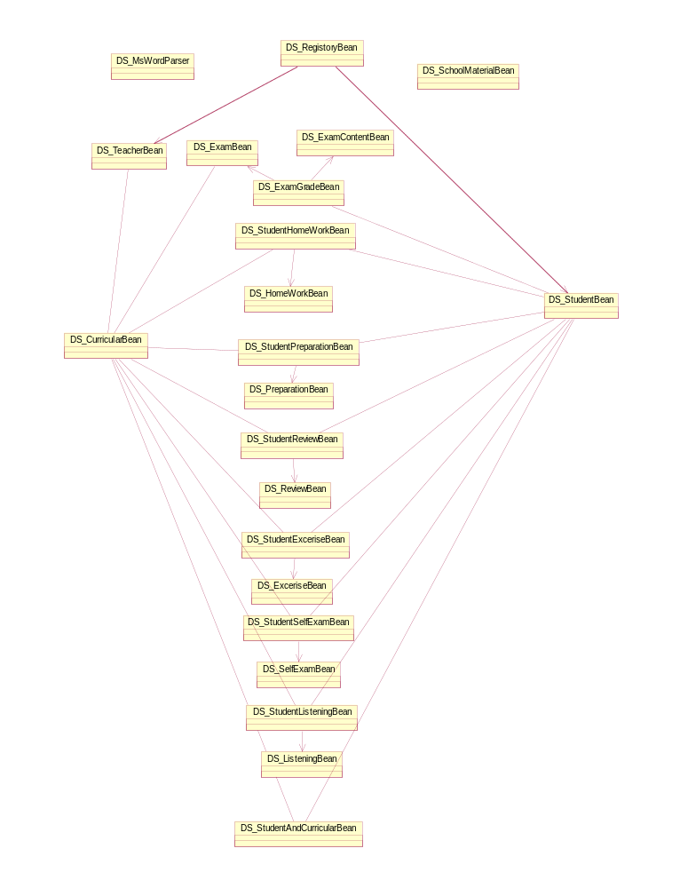

部分objects 列表

DS_CourseBean
DS_CourseStudentBean
DS_ProjectBean
DS_UsersBean
DS_ClassBean
DS_SchoolResourceBean
DS_SubjectBean
DS_PrejectCntentBean
DS_ContentBean
DS_AnserItemBean
DS_ExaminationBean
DS_HomeworkBean
DS_HomeworkContentBean
TestResultItemBean

DS_RegistryBean
DS_MsWordParser
DS_CheckHomeworkBean
DS_CheckAnswerBean
DS_ExamAnalysisBean
DS_SelectProjectBean
DS_SelectProjectinfoBean

其它Packages:
Servelet objects
JSP scripts

部分Objects 说明:

DS_RegistryBean
Attribute: SesionBean;
Relationship:
Description:
用于用户登录时，核对口令
Functions:
- checkPassword：核对口令

DS_MsWordParser
Attribute: Class;
Relationship:
Description:
用于解析 MSWord 文件，使之生成HTML或 GIF文件
Functions:
1. wordParser ：解析 MSWord 文件，使之生成HTML或 GIF文件

DS_CourseBean
Attribute：EntityBean
Relationship:
Description:
用于管理课程的信息，包括ID,教师ID，说明，时间等
Functions:
- createCurricular:
- RemoveCurricular;
  - SelectBy***

DS_StudentBean
Attribute：EntityBean
Relationship:
Description:
用于管理学生的信息，包括ID,姓名，信息说明，口令等
Functions:
1. createStudent:
- RemoveStudent;
- SelectBy***

DS_TeacherBean
Attribute：EntityBean
Relationship:
Description:
用于管理教师的信息，包括ID,姓名，信息说明，口令等
Functions:
1. createTeacher:
- removeTeacher;
- SelectBy***

DS_StudentAndCourseBean
Attribute：SessionBean
Relationship:
Description:
用于管理学生与课程的信息，包括学生ID,课程ID
Functions:
1. createStudentAndCurricular:
- removeStudentAndCurricular;
3. SelectBy***

DS_ExamBean
Attribute：EntityBean
Relationship:
Description:
用于管理考试的信息，包括ID,课程，说明，时间等
Functions:
- createExam:
- removeExam:
- selectByCoursIDAndTime: 通过课程ID和时间获取考试信息
- selectByPrimaryKey：通过考试ID获取考试信息
- selectByTeacherID:
…
DS_ExamContentBean
Attribute：EntityBean
Relationship:
Description:
用于管理考试内容的信息，包括ID,考题，答题纸，标准答案，说明，时间等
Functions:
1.createExamContent:
2.RemoveExamContent;
3.SelectBy***

DS_ExamGradeBean
Attribute：EntityBean
Relationship:
Description:
用于管理学生考试成绩的信息，包括学生ID,考试ID，考试内容ID，学生答题内容，成绩等
Functions:
1 createExamGrade:
- RemoveExamGrade;
- SelectBy***

DS_SchoolResourceBean
Attribute：EntityBean
Relationship:
Description:
用于管理学校资料的信息，包括ID,资料分类，资料内容，资料说明，时间等
Functions:
1. createSchoolMaterial:
2. RemoveSchoolMaterial;
- SelectBy***

DS_HomeWorkBean
Attribute：EntityBean
Relationship:
Description:
用于管理作业资料内容的信息，包括ID,作业内容，作业说明，时间等
Functions:
1. createHomeWork:
2. RemoveHomeWork;
3. selectBy***

DS_StudntHomeworkBean
Attribute：EntityBean
Relationship:
Description:
用于管理学生作业的信息，包括学生ID,作业ID，学生作业答案，课程等
Functions:
1. createStudntHomework
2. removeStudntHomework
3. selectBy***

Process View

Deployment View
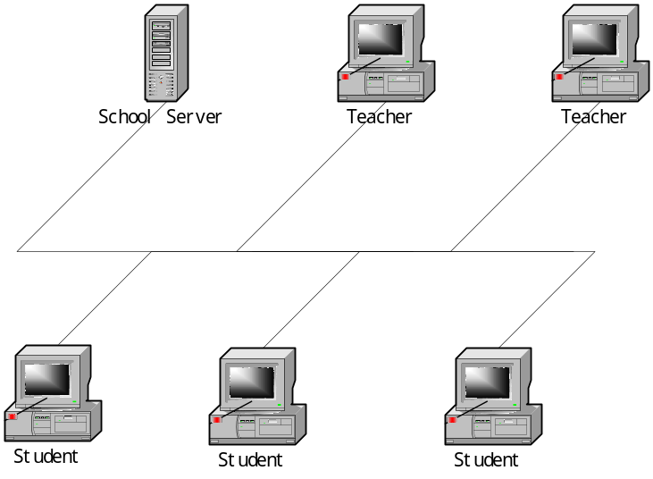

Implementation View

Overview

The architecture of eshool software can be divided into tow parts:
Education in school: Java Application run on computer of students and teachers, and Java beans run on the school server.
Education after school: jsp pages on computers of students and teachers, and Java beans run on the school server. For more details see 8.2

Layers

8.2.1课堂教学：

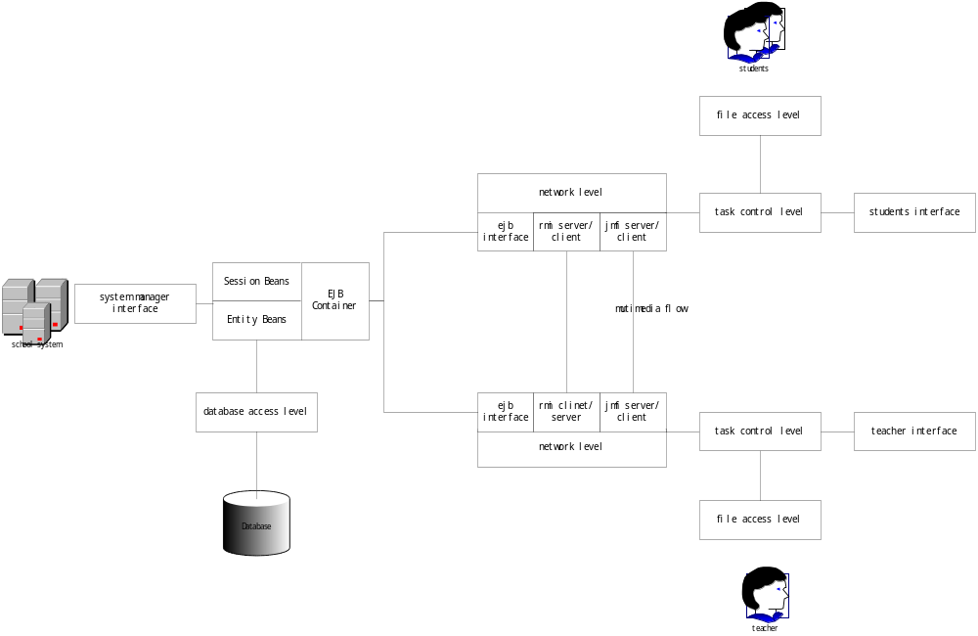

Implementation view 图1

8.2.2 课外教学
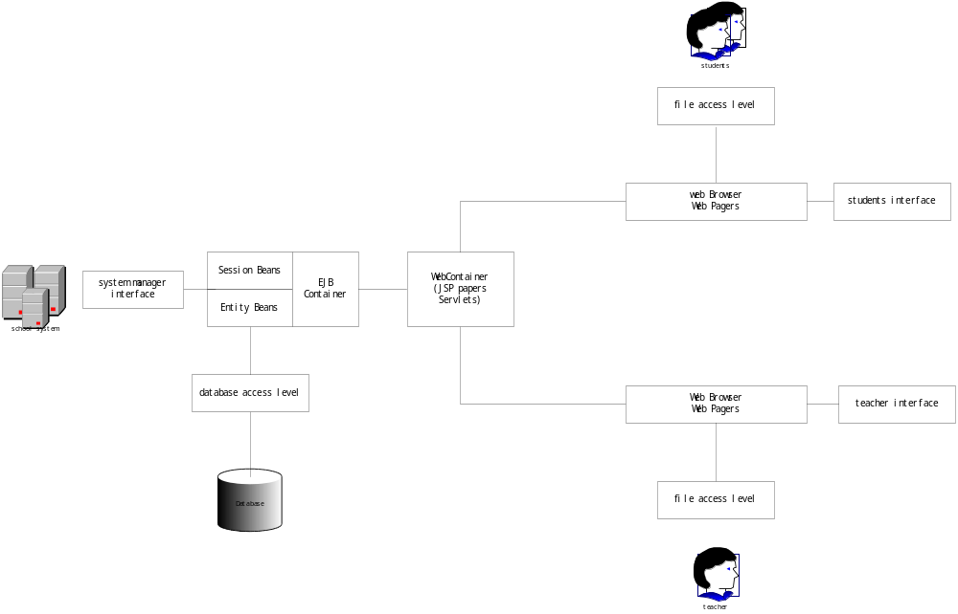

Implementation view 图2

Data View
Eschool database access architecture is modeled according as J2EE architecture. EJB container will mainly do the work about the persistence of data. And the synchronization of access will be controlled also by EJB container—J2EE server of SUN

Quality
The security of this system will be decided by operation security system, database security system, and this software privilege check system.
The robust of this system may depend on the robust of this software and J2EE server and Tomcat and progresql database and windows and linux operation system.

Supplementary Specification

Usability
The system management may need mast the security of the computer system besides the operation about how to manage the students, teachers, courses, privilege and web pages.
The system will present all graphic user interfaces, user can more easily to mast the use of this system.

Reliability
No grievous problem happened with 1000 hours.

Performance
Refer to requirement document.

Scaling Issues

The Scaling of the system depend on which of the level happened, it will be more easily to scale the system as the level of this system are almost independent.

11.5 Software condition requirement
- Linux RedHat 7.1 (kernel 2.2.4);
- Widnows2000
- MSWord 2000
- postgresql 7.1.3
- SUN J2EE 1.2.1
- JDK1.3.1
- ANT 1.3
- Tomcat(j2ee include)
- JMF 2.1.1
- Desktop(Jbuild Enterprise 5.0)

